

Quant in your pocket

NUS Orbital 2026

Milestone 1

Video Figma Log sheet

By O(Alpha)
Zhao Shizhen (A0322526L)
Tan Jia Jun (A0321311A)

Table of Contents
Section | Subsection | Page
Foreword |  | 4
Introduction |  | 5
 | Admin | 5
 | Proof of concept | 6
 | Setup Guide | 7
 | Our Aim | 8
 | Our Motivation | 8
 | User stories | 9
Features |  | 13
 | Features Overview | 13
 | Login | 16
 | Onboarding | 17
 | Dashboard | 22
 | Portfolio | 24
 | Agent Settings | 26
 | Activity | 28
 | Landing Backtest | 29
UML Diagrams |  | 32
 | Software Architecture diagram | 32
 | User Flow Diagram | 32
Database Diagram |  | 35
 | users | 36
 | sessions | 37
 | agent_settings | 37
 | accounts | 38
 | assets | 38
 | bars | 39
 | universes | 39
 | universe_members | 40
 | strategy_configs | 40
 | backtest_runs | 41
 | backtest_trades | 41
 | portfolio_backtest_runs | 42
 | sleeve_returns | 42
 | ml_model_artifacts | 43
 | pair_candidates | 44
 | strategy_trials | 45
 | agent_runs | 45
 | orders | 46
 | fills | 47
 | positions | 48
 | cash_ledger | 48
 | portfolio_snapshots | 49
 | system_alerts | 49
Technical Overview |  | 50
 | Single-symbol Kalman filter and state-space model | 50
 | Kalman mean-reversion signal (Z-score) | 51
 | Moving-average crossover | 53
 | Execution semantics | 54
 | Performance and risk metrics | 54
 | API-exposed model and strategy families | 55
 | Parameter reference | 56
 | Portfolio catalog strategy path | 56
 | DB-backed paper execution router | 57
 | Portfolio worker run loop | 58
 | HMM regime runtime overlay | 58
 | Streaming portfolio backtests | 58
 | Research and artifact constraints | 58
 | API Endpoints | 60
Architectural Philosophy |  | 67
 | Decoupled architecture and separation of concerns | 67
 | System dataflow path | 67
 | Core architecture components | 67
 | Architectural segregation | 68
 | Design patterns: DRY and KISS | 68
 | Concurrency, isolation, and lifecycle safety | 70
 | Data integrity by construction | 70
Quality Assurance |  | 72
 | Quality Control Stages | 72
 | Continuous Integration | 72
 | Continuous Deployment | 72
Milestone Planning |  | 73
Future Roadmap |  | 77
 | Monetization Strategy | 77
 | Final Reflection | 77

Foreword
Dear Reader,
This report serves as an open window into O(Alpha), chronicling our entire journey from an initial spark of an idea to a functional execution, alongside the engineering philosophy that drove our development.
To give you a transparent look at how the system builds and scales under the hood, we have included comprehensive application mockups, technical diagrams, and detailed architectural documentation.
As you dive in, please note that this is our current Proof of Concept (POC). The baseline styling, aesthetics, and user interface are still evolving, meaning the live app will look quite different from the finalized design concepts shown here. This phase is entirely about proving the core mechanics and robustness of our engine.
We warmly invite you to explore O(Alpha), push its boundaries, and share your candid feedback with us. Your insights are what will help us iterate faster and take this product to greater heights.
Thank you for being a part of our journey.
Warm regards,
Shizhen & Jiajun

Introduction

Admin
Team name: O(Alpha) (Team 6645)
Proposed level of achievement: Apollo

Overview
O(Alpha) is a high-performance quantitative trading and portfolio execution platform designed to automate market analysis, strategy generation, and trade execution through mathematical modeling and predictive algorithms.
The platform integrates continuous market scanning, statistical filtering, and regime-aware execution into a unified system capable of processing live asset streams in real time. By reducing reliance on emotional decision-making and manual chart interpretation, O(Alpha) aims to provide users with a more systematic and data-driven trading experience.
The system architecture is built around a decoupled infrastructure:
- Backend Execution Engine (Go): Handles high-speed computation, signal generation, portfolio simulation, and execution pipelines.
- Frontend Terminal Interface: Focuses on dense financial visualization, real-time telemetry, and intuitive strategy configuration while remaining isolated from latency-sensitive backend operations.
O(Alpha) currently supports multiple quantitative strategy frameworks across two execution surfaces:
- Single-symbol Kalman Filter
Uses predictive filtering and statistical deviation analysis for the landing-page backtest and legacy symbol-agent path.
- Single-symbol Moving Average Crossover
Detects trend-following crossover events and remains the default base strategy for several educational and ML-meta-label flows.
HMM Ensemble / Regime Overlay
API-exposed single-symbol agent mode that combines MA and Kalman votes while using an HMM risk overlay for regime state and sizing context.
ML Meta-Label Strategy
API-exposed wrapper that loads a model artifact, builds features, calibrates probabilities, and filters or sizes base MA/Kalman entry signals.
Portfolio Catalog Strategies
Primary paper-trading path built on multi-symbol PortfolioStrategy implementations: LGBM h63 ranker sleeves, deterministic h63 proxy sleeves, low-volatility diagnostics, ranked sleeves, benchmark-funded TSMOM, and composite momentum challengers.
Portfolio Research Backtests
/api/v1/backtest also exposes XSEC_MOMENTUM and KALMAN_COINTEGRATION for multi-symbol research simulations.
The platform continuously processes live price streams and transforms them into systematic trading signals through automated mathematical pipelines.
Current implementation update
The latest implementation is now a full-stack research and paper-trading system rather than a frontend-only proof of concept. The backend exposes authenticated REST/NDJSON APIs, runs portfolio backtests, starts and stops one portfolio catalog agent per user, and persists paper fills, positions, portfolio snapshots, agent run state, and alerts into Postgres.
The primary paper-trading path is the portfolio catalog path. A user chooses a catalog strategy, validates it through a backtest, launches a daily-bar portfolio worker, and watches the dashboard update from real backend state. The system remains paper-only by design; live-money brokerage execution is outside the current product scope.

Proof of concept
Video
https://drive.google.com/file/d/1cLmldqooo7drd9C3rpafV5F6Xso6HH80/view?usp=sharing

Deployed Frontend
Note: the deployed frontend can be viewed at the Vercel URL. Backend-backed flows require NEXT_PUBLIC_API_URL to point at a running Go API. Locally, the full API + frontend stack works through make run-api or make up.
App dashboard can be accessed via
Login -> “Demo Onboarding” -> app dashboard
https://o-alpha-tan.vercel.app/

Setup Guide
Step 1: Clone the repository
git clone https://github.com/shiverin/O-Alpha.git
cd O-Alpha
Step 2: Create the Docker environment file
Run: make setup-docker
This copies .env file from the Docker template:
.env.docker -> .env

Step 3: Add Alpaca keys (Optional)
Open the .env file and fill in your Alpaca credentials:
ALPACA_API_KEY=YOUR_KEY
ALPACA_API_SECRET=YOUR_SECRET
(Can leave them blank for now.)

Step 4: Start the full Docker stack
Run: make up
This builds and starts all containers.

Step 5: Open the app
Once the containers are running, access frontend at:
http://localhost:3000

The backend API should be available at:
Local full-stack setup notes
For fast Supabase-backed local development, run make setup-local, edit DATABASE_URL and NEXT_PUBLIC_API_URL in .env, then run make migrate and make run-api. Start the frontend separately from frontend/ with npm install and npm run dev.
For Docker development, make setup-docker copies .env.docker to .env and make up starts the TimescaleDB, Redis, API, ingest, and frontend services. The frontend should be available at http://localhost:3000 and the API at http://localhost:8080.
When testing LGBM ranker catalog strategies, mount the model artifacts read-only and set OALPHA_DAILY_RANKER_ARTIFACT_ROOT=/var/lib/oalpha/models/fold_artifacts. The API should fail closed when required ranker artifacts are missing rather than silently falling back to proxy logic.
http://localhost:8080

Our Aim

O(Alpha) aims to provide an accessible, intelligent, and automated trading platform that allows both beginners and experienced traders to participate in financial markets with greater confidence and reduced emotional bias.
By combining quantitative finance, predictive analytics, and real-time execution systems, we seek to simplify complex trading workflows into a seamless and intuitive experience.

Our Motivation

Modern trading environments are increasingly complex and data intensive. Many retail traders struggle with:
- Information overload from rapidly changing markets
- Emotional decision-making during volatile conditions
- Difficulty identifying reliable trading signals
- Poor risk management and capital allocation
We realized that most existing trading platforms either:
- Require deep financial knowledge and manual analysis, or
- Provide simplistic tools that fail under changing market conditions
As a result, many individuals entering the trading world are unable to make informed and disciplined decisions.
O(Alpha) was created to bridge this gap by automating signal processing, filtering market noise, and adapting strategies dynamically based on changing market regimes. Our goal is to reduce cognitive burden while enabling smarter, more consistent portfolio execution through quantitative systems.

User stories

User | User Story Statement | Priority | Technical Implementation
Systemic Trader | As a systemic trader, I want a dark, ultra-minimalist, monochrome terminal workspace so that I can monitor real-time statistical metrics without interface distractions. | Essential | Implements a high-density, low-fatigue layout matching the Ethereal Monolith style specification, using deep container layers and high-contrast numerical tracking.
Statistical Analyst | As a statistical analyst, I want to toggle between mean-reversion and momentum engines instantly to test distinct mathematical strategies. | Essential | Segmented engine selector in the control configuration block that switches input fields and request payload states between Kalman and Crossover spaces.
Quant Engineer | As a quant engineer, I want precise control over process noise variables to fine-tune how fast the estimation engine tracks true asset values. | Typical | Custom-built range input sliders optimized for 0ms physical dragging latency, adjusting step metrics at a 0.001 scale before committing parameters.
Risk Manager | As a risk manager, I want to set market noise rejection thresholds ($R$) to ignore random price spikes during periods of high volatility. | Typical | Dynamic track-filled slider mapping adjustments directly to the measurement noise parameters of the state-space equations.
Execution Trader | As an execution trader, I want to define trade triggers using precise standard deviation boundaries to protect entries. | Typical | Tactile range inputs displaying execution boundaries on a mono-spaced layout, with active compression feedback on user press.
Fund Allocator | As a fund allocator, I want to view dynamic YTD cumulative P&L metrics so that I can evaluate strategy performance across active fiscal cycles. | Essential | Sliced timeframe arrays updating large numerical displays in real time via custom client-side data aggregation wrappers.
Risk Auditor | As a risk auditor, I want a clear visualization of real-time Sharpe and Sortino Ratios to confirm our active strategies stay within optimal portfolio parameters. | Typical | Asymmetrical telemetry modules using custom border glows to isolate critical portfolio efficiency values.
Compliance Officer | As a compliance officer, I want a visual tracking tool for Maximum Drawdown to ensure our running simulations don't cross our hard risk limits. | Essential | Sleek linear progress metrics mapped to safe surface container tokens, tracking current drawdown states down to the pixel.
Macro Allocator | As a macro allocator, I want automated market regime detection so that the system automatically identifies structural changes in market conditions. | Typical | Three-tier horizontal telemetry bar chart visualizing state classifications (Bull, Volatile, Bear) returned by continuous underlying algorithms.
Execution Developer | As a backend developer, I want to adjust strategy parameters smoothly without triggering page lag or flooding the execution layer with micro-updates. | Essential | "Commit-on-release" parameter caching using pointer handlers to delay API transmission until the user stops adjusting a slider thumb.
Technical Auditor | As a technical auditor, I want to view a detailed text summary of our risk architecture constraints directly inside the operational dashboard space. | Novel | Static narrative container modules using fine layout typography to break down complex underlying mathematical concepts for the user.
Systems Engineer | As a systems engineer, I want the client app to send typed, validated request payloads to our Go backend to prevent engine compilation and runtime failures. | Essential | Shared TypeScript interface structures connecting the front-end parameters directly to the backend API schemas.
Portfolio Agent User | As a portfolio user, I want to launch one paper portfolio agent that runs a chosen catalog strategy over a curated universe so that my dashboard reflects real persisted paper state. | Essential | POST /api/v1/agent/portfolio/start creates a PORTFOLIO_CATALOG run, starts the portfolio worker, and persists fills, positions, snapshots, and alerts.
Research Auditor | As a research auditor, I want each strategy to show paper-only status and evidence paths so that I can tell what is validated and what is only experimental. | Essential | GET /api/v1/strategies/catalog returns deployment_status, promoted_checkpoint, evidence_paths, paper_only, and requires_model_artifacts metadata.
New User | As a new user, I want to see the backtest graph build while onboarding so that accepting a strategy feels grounded in actual simulation output. | Essential | POST /api/v1/backtest/stream emits NDJSON progress events consumed by runBacktestStream and rendered by EquityCurveChart.
Portfolio Monitor | As a portfolio monitor, I want allocation, P&L, execution logs, and alerts to come from stored backend state instead of mock data. | Essential | Dashboard fetches /user/portfolio/summary, /history, /positions, /trades, /alerts, /live, and /agent/list through SWR and the API client.

Features

Features Overview
S/N | Feature | Completed At (Milestone) | Brief Explanation
Core Features
1 | Back Testing | 1 | Landing-page strategy simulator for Kalman and MA crossover / momentum backtests, showing parameter controls, equity curve, and risk metrics.
2 | Login | 1 | Authentication for logging in (for returning users) and sign up (for new users)
3 | Onboarding | 1 | First-time authenticated users select a risk profile, run a matching paper-only catalog backtest, accept the result, and only then unlock the dashboard.
4 | Dashboard | 1 | Main authenticated overview: portfolio value, regime-aware agent status, launch/terminate control, simplified risk/universe display, allocation, and recent fills.
5 | Agent Settings | 1 | Configuration screen for risk profile and trading constraints, with catalog strategy validation and streaming backtest acceptance before profile changes.
6 | Portfolio | 1 | Detailed holdings and allocation view backed by portfolio summary, positions, history, live price marks, and CSV export.
7 | Activity Logs | 1 | Audit console for persisted executions and system alerts, with action/asset filters and CSV export.
8 | Paper Trading Engine | 2 | Live background agent workers that execute simulated trades against real-time market data
9 | Hidden Markov Model (HMM) Regime | 2 | Three-state, nine-symbol forward-filter HMM that classifies market regime as Low-Vol Trend, Medium, or High-Vol Stress
10 | HMM Risk Overlay & Safety Triggers | 2 | Regime-aware exposure multiplier with hysteresis, crisis de-risk, realized-vol cap, and drawdown guard
11 | HMM Ensemble Decision Layer | 2 | Regime-weighted MA + Kalman ensemble that adjusts signal weights and position sizing by market regime
12 | Pairs Trading Engine (Kalman Cointegration) | 2 | Two-state Kalman hedge filter tracking cointegration spread, with Z-score entry/exit, stop-loss quarantine, and periodic pair retesting
13 | ML Meta-Label Strategy | 2 | Machine-learning gating layer that filters base-strategy buy signals through a probability model with 47-feature vector and calibration
14 | Portfolio Backtest Engine | 2 | Multi-symbol portfolio simulator with cost model (spread, slippage, commission), aligned bar panels, and per-sleeve risk overlay
15 | Strategy Catalog | 2 | Paper-only catalog strategies organized by risk profile, with deployment status, evidence paths, benchmark symbol, and model-artifact requirements.
16 | Websocket Market Data Streaming | 2 | Real-time Alpaca WebSocket connector with auto-reconnect for low-latency bar delivery to live agents
17 | Portfolio Agent Manager | 2 | Multi-symbol portfolio worker orchestration with concurrent execution, per-sleeve telemetry, and graceful lifecycle management
18 | Enhanced Database Schema | 2 | Alpha-foundation tables for universes, portfolio backtest runs, sleeve returns, model artifacts, pair candidates, and strategy trials, plus dataset-aware bar storage.
19 | Backtest Streaming Endpoint | 2 | NDJSON streaming endpoint for progressive portfolio equity-curve delivery during onboarding and agent-settings validation.
20 | Agent List & Strategy Catalog APIs | 2 | New endpoints to enumerate running agents and browse available portfolio strategies
21 | DB-backed Portfolio Execution Router | 2 | Converts target weights into idempotent paper fills, cash ledger updates, positions, portfolio snapshots, and rebalance/risk alerts.
22 | Portfolio Live State Stream | 2 | Streams snapshots and latest price marks to keep dashboard summary, allocation, and history synchronized with backend state.
23 | Artifact-aware Ranker Runtime | 2 | LGBM ranker strategies read local model artifacts from OALPHA_DAILY_RANKER_ARTIFACT_ROOT and fail closed when artifacts are absent.

Login
Our login process consists of a singular screen to capture authentication credentials and securely initiate a user session. The client interface is optimized to minimize user drop-off by eliminating registration screens, managing both security credential capturing and application routing within a single procedural flow.
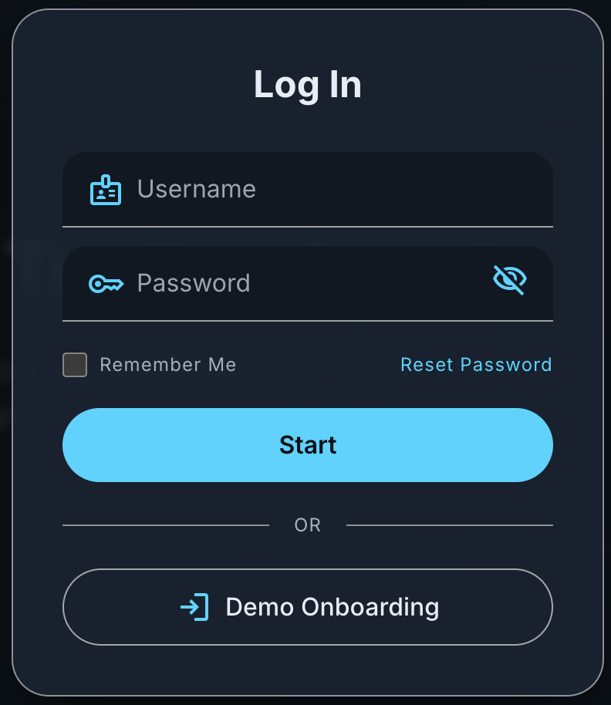
Upon filling in username and password, and pressing “Start”, the component delivers an asynchronous payload to the /auth/login endpoint on the Go backend which validates identity by performing bcrypt password hash comparisons. Upon verification, the server generates a cryptographically signed, stateless JSON Web Token (JWT) using the HMAC-SHA256 signature algorithm. The client-side application context intercepts and persists this token payload to authorize all subsequent requests to protected resource routes (/api/v1/*) across the system framework.
If the database evaluates that a submitted username does not exist, the backend automatically branches into an auto-registration script that hashes the new credentials using bcrypt, commits the user record, and initializes the system onboarding state to false.
When this token is passed back to the client interface, the global auth context detects the incomplete onboarding state and intercepts the routing process. This instantly displays an onboarding overlay view before unlocking dashboard.
Onboarding
For a seamless onboarding process, first-time authenticated users no longer stop at risk-profile selection. They begin setup, choose a risk profile, review a matching paper-only catalog strategy, run a five-year portfolio catalog backtest, and accept the result before the dashboard is unlocked.
The risk-profile screen uses an explicit Next button so ordinary card clicks only select the profile. The following screen loads /api/v1/strategies/catalog, filters strategies by the selected risk bucket, shows the available strategy cards, and renders return, Sharpe, max drawdown, trades, and the equity curve for the chosen strategy.
Start Backtest calls POST /api/v1/backtest/stream with a PORTFOLIO_CATALOG payload, the full default universe, the chosen strategy_key, and risk-derived settings. Accept Backtest remains disabled until a completed result exists; accepting saves /api/v1/user/settings and then calls /api/v1/user/onboarding/complete with backtest_accepted=true.
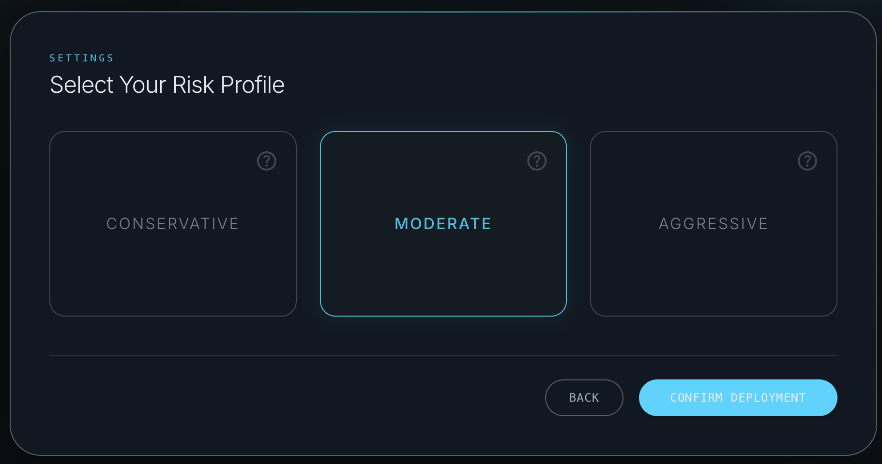

The second onboarding screen, shown below, is the acceptance gate. The user can compare catalog strategy cards, inspect the generated metrics and equity curve, rerun the test, or accept the backtest to persist their configuration.
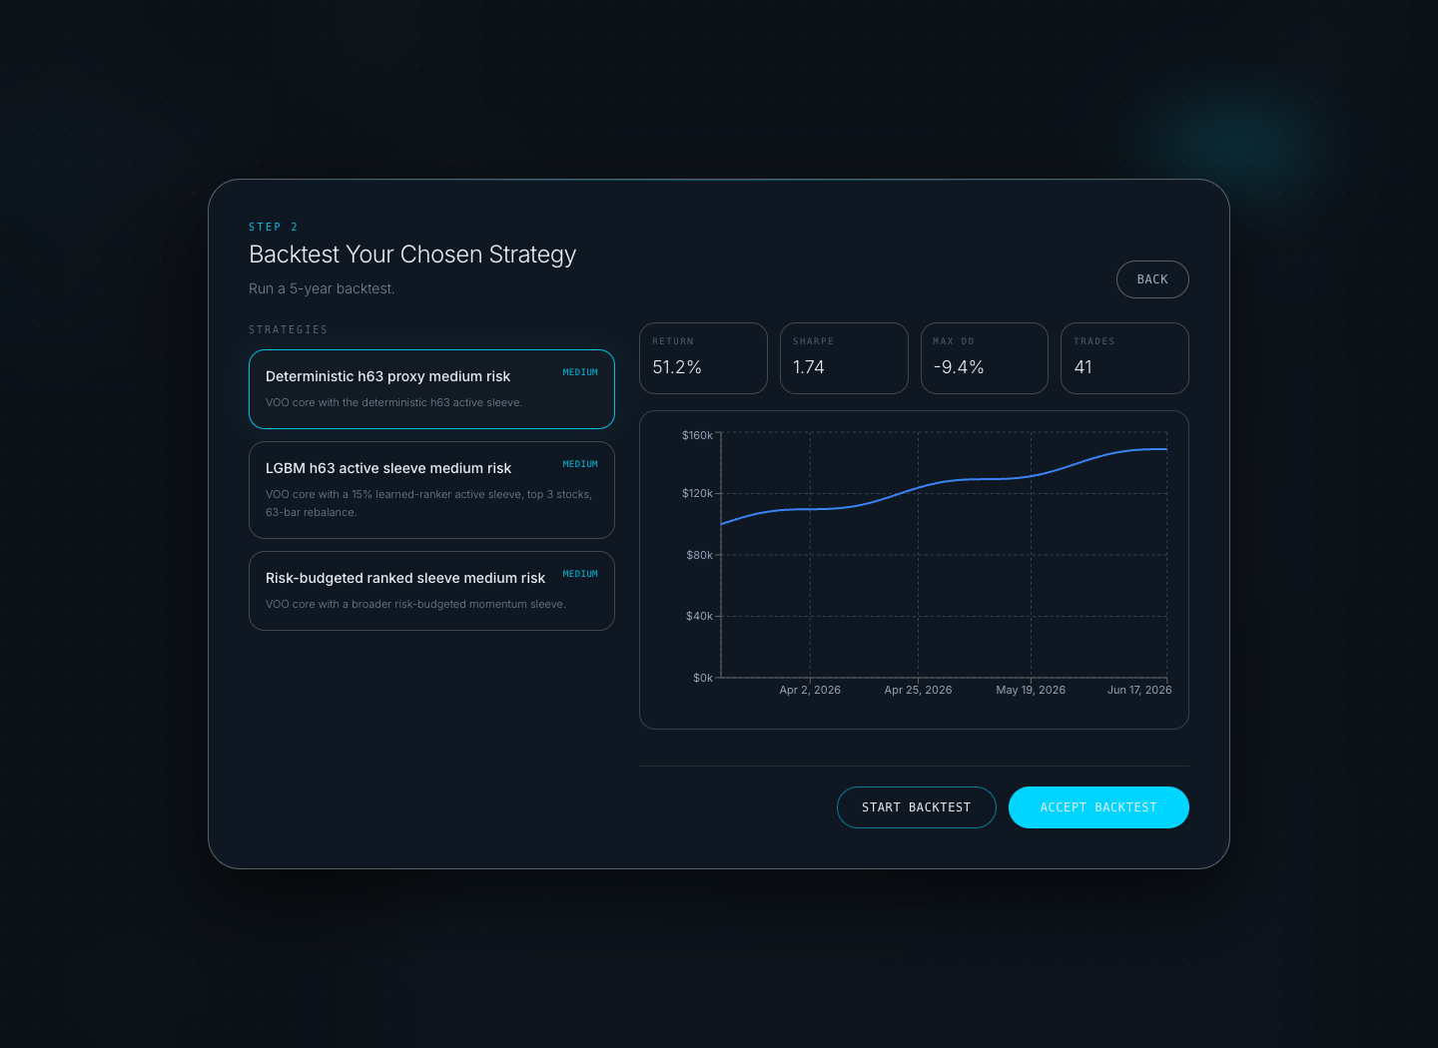

Technicalities and Motivations

Frontend
Topic | Explanation
Reason for necessary fields | To drastically lower user acquisition friction, we eliminated traditional separated signup flows. The single form requires only a Username and a Password.  During the subsequent agent onboarding wizard, the only strictly required user-driven field is the selection of a global Risk Profile (CONSERVATIVE, MODERATE, or AGGRESSIVE). This field is mandatory because the algorithmic backend cannot safely instantiate predictive models or backtests without a bounding risk metric to dictate parameters like leverage limits and stop-loss margins.
Onboarding UI flow | The wizard is now a deliberate three-step flow: welcome, risk-profile selection, and catalog backtest acceptance. Risk cards select only the profile; an explicit Next button advances to the backtest screen.
Catalog strategy cards | The frontend loads /api/v1/strategies/catalog, filters strategies by the selected low/medium/high risk bucket, and renders selectable strategy cards with display name, risk label, and description.
Error and disabled states | State flags disable Back, strategy selection, Start Backtest, and Accept Backtest while the catalog is loading, the backtest is running, or settings are being saved. Backend errors render inline instead of silently advancing the user.
Backtest acceptance gate | Start Backtest streams a PORTFOLIO_CATALOG simulation through runBacktestStream. Progress points progressively build the chart, final metrics populate the tiles, and Accept Backtest stays disabled until backtestResult is present.
Completion handoff | After acceptance, the client saves risk-derived settings, completes onboarding with risk_profile, strategy_key, and backtest_accepted=true, then calls onComplete so the dashboard can hydrate from the selected profile and strategy.

Backend
Topic | Explanation
Unified Authentication Handler | When the frontend hits the authentication endpoint, the controller logic first executes an existence check on the provided unique username.  If the username does not exist, the backend seamlessly triggers a sign-up mechanism: it hashes the password, instantiates a new user document profile with default parameters, and flags the user record with onboarded: false. It then immediately signs the user in to start the onboarding, bypassing the need for a separate registration step.
Catalog and risk validation | GET /api/v1/strategies/catalog returns the default universe, recommended risk-profile map, and StrategySpec metadata. Onboarding uses this to ensure the selected strategy belongs to the chosen risk bucket.
Backtest stream gate | POST /api/v1/backtest/stream accepts portfolio strategies only. For onboarding it receives strategy_type=PORTFOLIO_CATALOG, symbols=default_universe, timeframe=1Day, initial_cash=100000, and parameters.strategy_key, then emits started/progress/completed/error NDJSON events.
Settings persistence | POST /api/v1/user/settings persists the risk-derived ServerAgentSettings payload: risk_profile, leverage, max_positions, stop_loss_pct, take_profit_pct, and rebalance_freq.
Onboarding completion guard | POST /api/v1/user/onboarding/complete requires backtest_accepted=true, a saved settings row for the selected risk profile, and a strategy_key whose catalog risk bucket matches the profile before flipping users.is_onboarded to true.

Dashboard
The dashboard is the authenticated command centre for paper trading. It surfaces the current portfolio P&L, active agent status, regime label, recent fills, allocation, and a simplified strategy profile card that only displays the user-facing risk profile and the selected asset universe size.
The launch button starts or terminates the one-user-one-agent portfolio flow. Once active, the screen hydrates from backend agent state, portfolio snapshots, positions, trades, and the live portfolio stream so values change when paper fills or price marks are persisted.
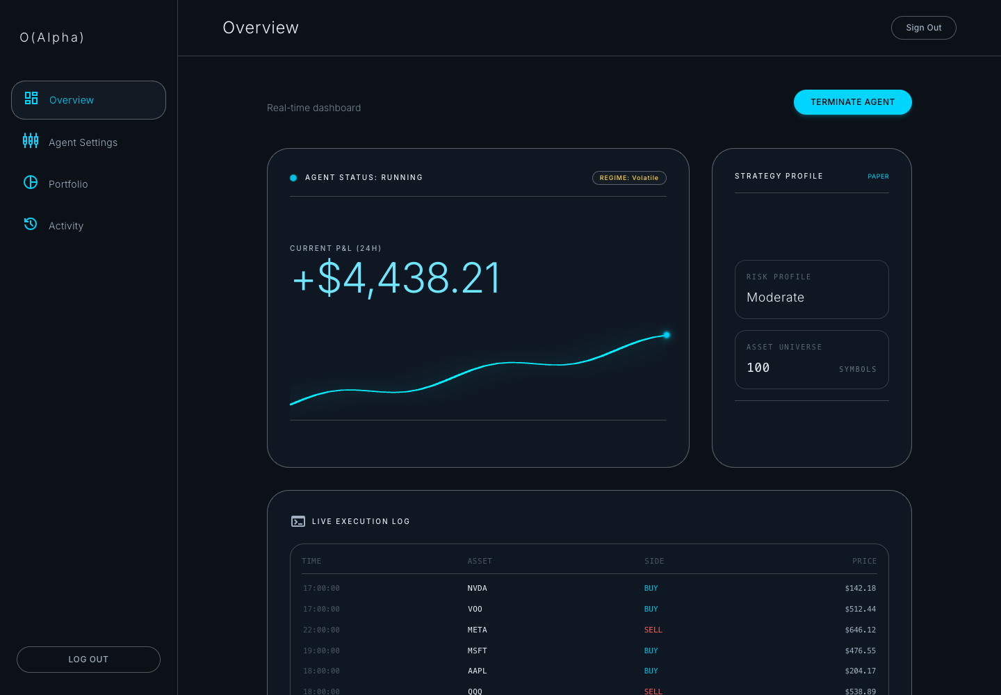
Technicalities and Motivations
Frontend
Topic | Explanation
Screen composition | The page composes BalanceCard, StrategyControls, ExecutionLog, and PortfolioAllocation inside AppShell. The strategy card is display-only and intentionally exposes only Risk Profile and Asset Universe.
State hydration | SWR loads /api/v1/user/portfolio/summary, /history, /positions, /trades, /strategies/catalog, and /agent/list. The active/idle state is derived from the backend agent list, not local component state.
Live updates | streamPortfolioLive patches summary, positions, and history in-place. Price events are applied through portfolioLiveState helpers so dashboard values and allocation can update without a full page refresh.
Agent control UX | The Launch/Terminate button calls portfolioAgentApi.start or stop, disables during synchronization, and renders backend errors in an inline alert panel.
Backend
Topic | Explanation
Agent state | GET /api/v1/agent/list returns active agent_runs with strategy_type PORTFOLIO_CATALOG, strategy_key, heartbeat, and runtime_state such as the synced regime label.
Portfolio state | Portfolio endpoints read canonical DB snapshots, positions, and fills. GetPortfolioSummary, GetPortfolioHistory, GetActivePositions, and GetExecutionStream all scope records to the authenticated user.
Launch/stop flow | POST /api/v1/agent/portfolio/start validates risk/profile strategy alignment, creates an agent_runs row, starts the portfolio orchestrator, and marks the run as running. Stop marks the active run stopped and writes an alert.
Streaming | GET /api/v1/user/portfolio/live emits NDJSON snapshots and price events. With Alpaca credentials, latest prices are marked into positions before snapshots are saved.

Portfolio
The portfolio screen expands the dashboard allocation into a holdings-centric view. Users can inspect total asset value, 24-hour change, composition, top performer, risk profile, target progress, and the live positions table in one place.
Unlike the marketing performance page, this screen is tied to persisted paper-trading state: positions, cash, current prices, unrealized P&L, and portfolio history come from the backend repository and are refreshed through the same live stream used by the dashboard.
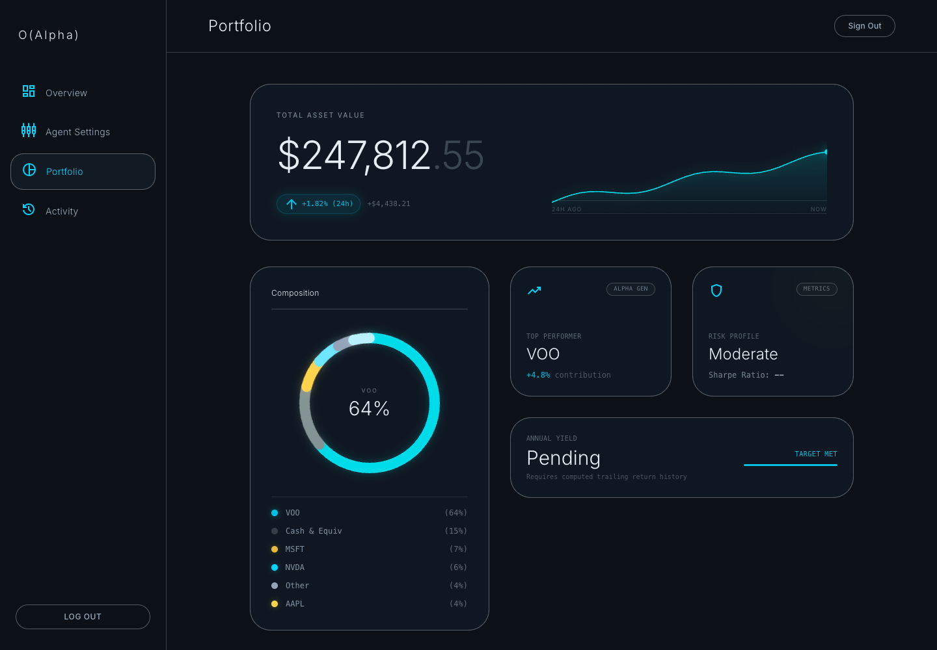
Technicalities and Motivations
Frontend
Topic | Explanation
Summary and charting | The page reads portfolio summary and history through SWR, then renders the total value, 24-hour change pill, and sparkline from chronological snapshot data.
Composition ring | Current positions are ranked by exposure, grouped into visible slices plus cash/other, normalized to percentages, and rendered as a donut allocation chart.
Live position table | The positions table uses server positions when authenticated and applies live price events to flash rows up or down when a quote changes.
Export and display controls | Users can expand beyond the default visible positions and export the current position set to CSV using the shared downloadCsv helper.
Backend
Topic | Explanation
Snapshot source | PortfolioRepository.SavePortfolioSnapshot computes cash, positions value, total asset value, realized/unrealized P&L, 24-hour change, and target progress from DB state.
Position source | GetActivePositions returns open long positions with qty, avg_entry_price, current_price, unrealized_pnl, and exposure for the authenticated user.
Price marking | refreshPortfolioMarks fetches latest Alpaca prices for open symbols, calls MarkPositionPrice, and records a fresh snapshot before serving portfolio reads.
Live stream | StreamPortfolioLive emits the latest summary, positions, and history first, then continues with Alpaca trade/price events or a timed snapshot fallback.

Agent Settings
Agent Settings lets the user manage risk posture and paper-agent constraints after onboarding. The visible cards map the user-friendly profiles to backend risk buckets, while the advanced controls store leverage, maximum positions, stop-loss, take-profit, and rebalance cadence.
Risk changes are deliberately gated. If a portfolio agent is running, the frontend blocks profile changes and tells the user to stop the agent first. When a risk profile changes, the user must run and accept a catalog backtest before the settings payload can be saved.
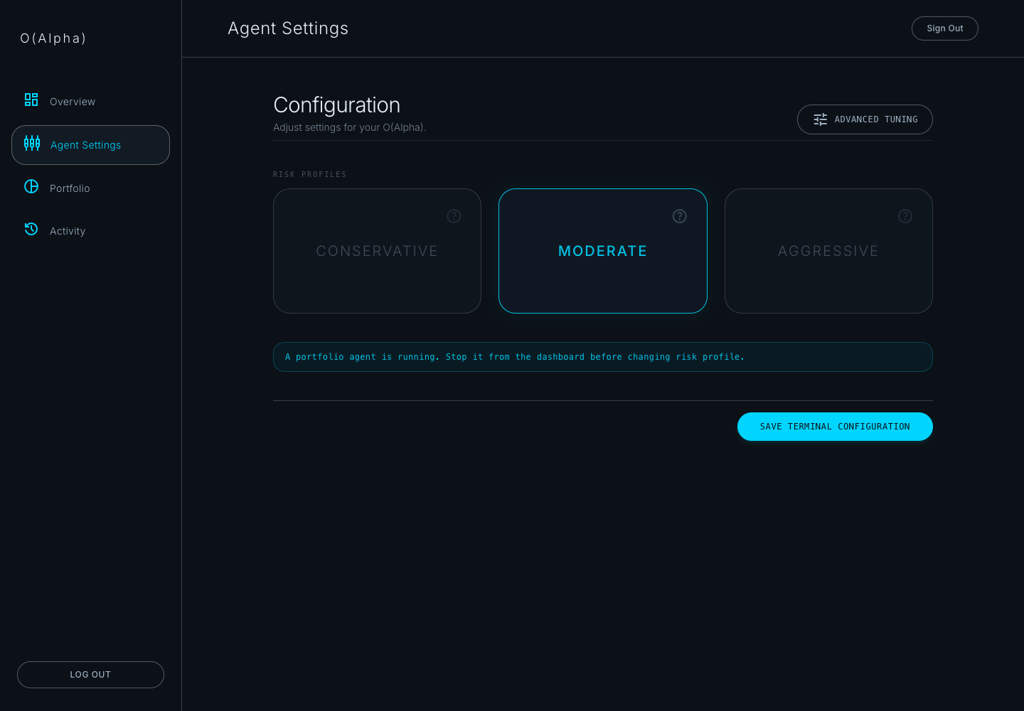
Technicalities and Motivations
Frontend
Topic | Explanation
Risk profile cards | The three profile cards use local state for selection and flip-state details, then compare the selected profile against the saved profile to determine whether validation is required.
Catalog strategy selection | The screen loads /api/v1/strategies/catalog, filters strategies by the chosen risk bucket, and defaults to the matching recommended catalog key.
Backtest validation | runBacktestStream powers the validation panel, progressively rendering equity points while the backend emits NDJSON progress events. Accept Backtest records the strategy key that passed validation.
Save gating | The Save button is disabled while backtesting/saving and when a changed profile has not been accepted, or when /agent/list reports a running portfolio agent.
Backend
Topic | Explanation
Settings read/write | GET /api/v1/user/settings returns saved agent_settings; POST /api/v1/user/settings validates bounds before upserting risk_profile, leverage, max_positions, stop_loss_pct, take_profit_pct, and rebalance_freq.
Running-agent guard | When risk_profile changes, SaveUserSettings checks ListActiveAgentRuns and rejects the update until the active portfolio agent is stopped.
Backtest acceptance guard | Risk-profile changes require backtest_accepted=true and a strategy_key whose catalog risk bucket matches the requested profile.
Runtime consumption | Portfolio runtime settings are converted into max gross exposure, active-position caps, stop-loss/take-profit exits, and rebalance eligibility inside the portfolio worker path.

Activity
The Activity screen is the audit console for the paper-trading system. It shows recent persisted execution records beside system alerts so a user can understand what the agent did and why it did it.
The interface supports action filters, asset filters, trade-limit selection, and CSV export. This makes the screen useful both as an end-user history page and as a debugging surface when validating agent behavior.
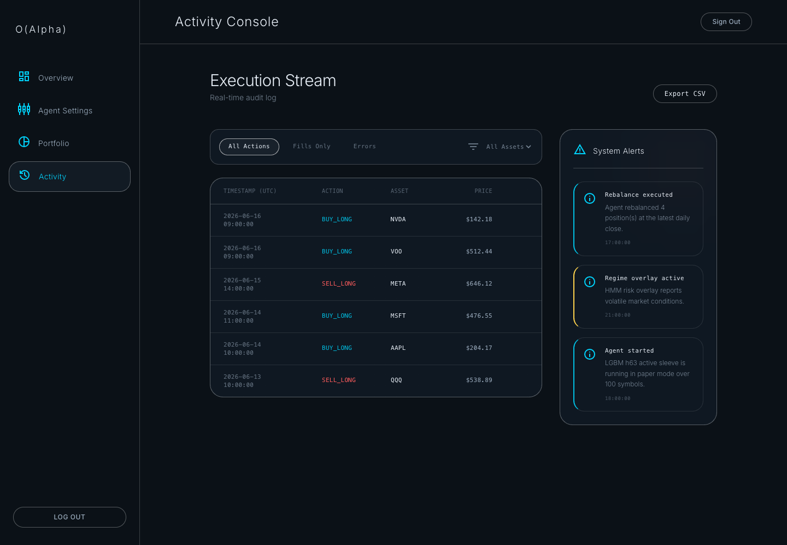
Technicalities and Motivations
Frontend
Topic | Explanation
Execution stream table | SWR reads /api/v1/user/portfolio/trades with a configurable limit, then renders timestamp, action, asset, price, size, slippage, and status.
Filtering | The toolbar filters by All Actions, Fills Only, or Errors, and the asset selector is derived from the unique symbols present in the loaded execution stream.
System alerts | The side panel reads /api/v1/user/portfolio/alerts and renders alert type, title, description, and UTC timestamp with visual severity treatments.
CSV export | The current filtered trade rows are exported through downloadCsv as oalpha-activity-log.csv, preserving the audit fields shown on-screen.
Backend
Topic | Explanation
Trade retrieval | GetExecutionStream reads fills joined to orders and normalizes sides into BUY_LONG, SELL_LONG, SELL_SHORT, or COVER_SHORT before returning the latest rows.
Alert retrieval | GetSystemAlerts returns recent user-scoped alerts from portfolio_alerts with limit clamping to prevent oversized reads.
Alert sources | Portfolio orchestrator and execution routers insert alerts for agent start, stop, resume, rebalance execution, risk exits, and resume failures.
Audit durability | Because activity reads from persisted orders, fills, and alerts, the screen survives refreshes and backend restarts instead of depending on transient frontend logs.

Landing Backtest
The landing-page performance screen lets non-authenticated visitors run a single-symbol backtest before signing in. The user enters a symbol, chooses between Kalman Filter and Momentum / MA Crossover, adjusts strategy parameters, and runs the simulation directly from the page.
Returned results populate the real-time metrics section with cumulative P&L, Sharpe ratio, max drawdown, and the equity curve. If the backend cannot run the request, the frontend falls back to a default curve and displays an error note rather than leaving the section blank.
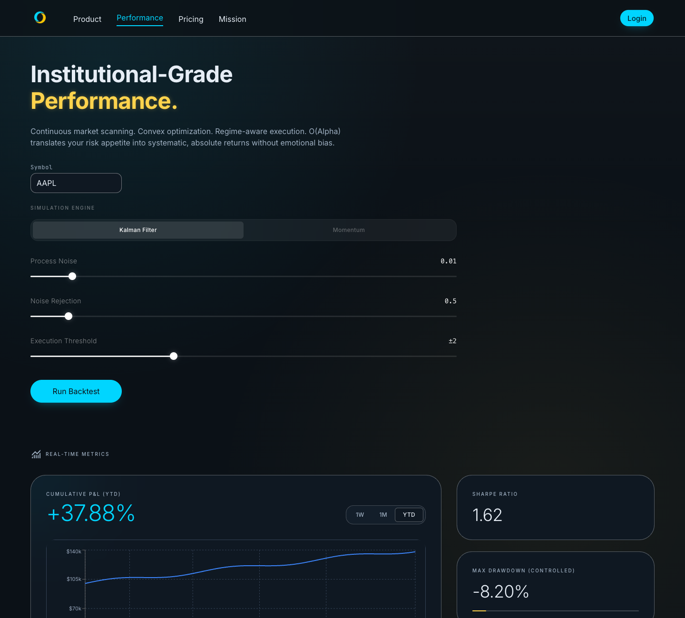
Technicalities and Motivations
Frontend
Topic | Explanation
Strategy selector | StrategySelector owns the Kalman vs Momentum toggle and emits a StrategyConfig containing q_noise, r_noise, z_threshold, fast_period, and slow_period.
Backtest request | PerformancePage builds a BacktestRequest using the selected symbol, one-year date range, 1Day timeframe, and selected strategy parameters before calling runBacktest.
Metrics rendering | TelemetryMetrics consumes the returned equity_curve and metrics to render cumulative return, Sharpe ratio, max drawdown, and the charted equity path.
Fallback behavior | If runBacktest fails, the page swaps in DEFAULT_EQUITY_CURVE and explains that fallback performance data is being displayed.
Backend
Topic | Explanation
Backtest endpoint | POST /api/v1/backtest parses BacktestRequest, defaults timeframe to 1Day and initial_cash to 100000, and loads bars from the repository for the requested symbol.
MA crossover validation | MA_CROSSOVER defaults to fast=10 and slow=30, rejects fast_period >= slow_period, then runs backtest.NewMACrossoverStrategy.
Kalman validation | KALMAN defaults q_noise=0.01, r_noise=0.5, z_threshold=2.0, and runs backtest.NewKalmanStrategy with a 20-bar lookback.
Data-quality gate | Before simulation, the backend calls ValidateData and rejects a backtest when invalid bars exceed the configured quality threshold.

UML DIAGRAMS
- Software Architecture diagram
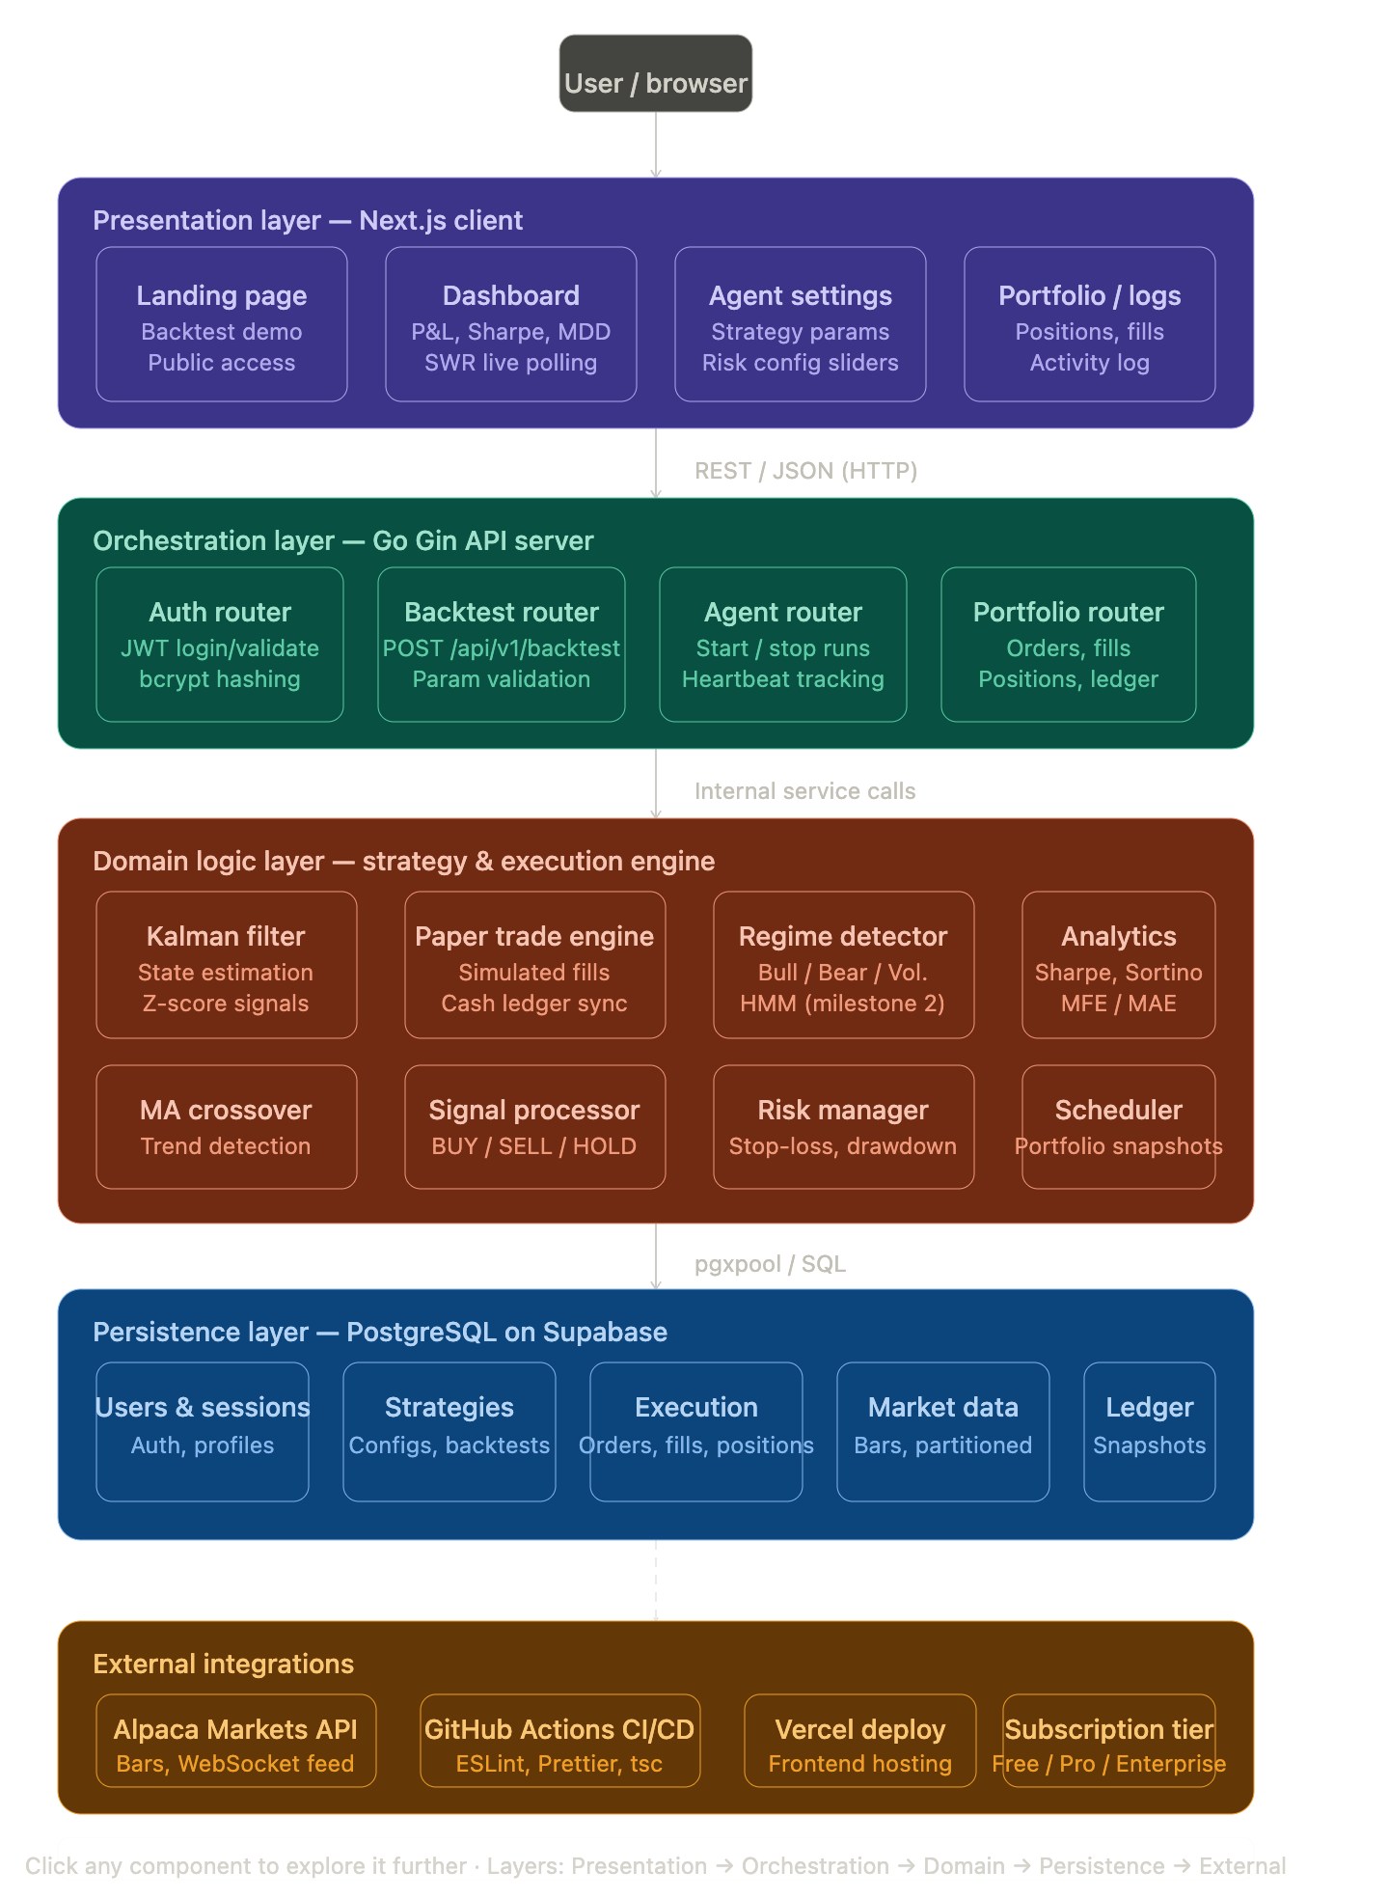
- User Flow Diagram
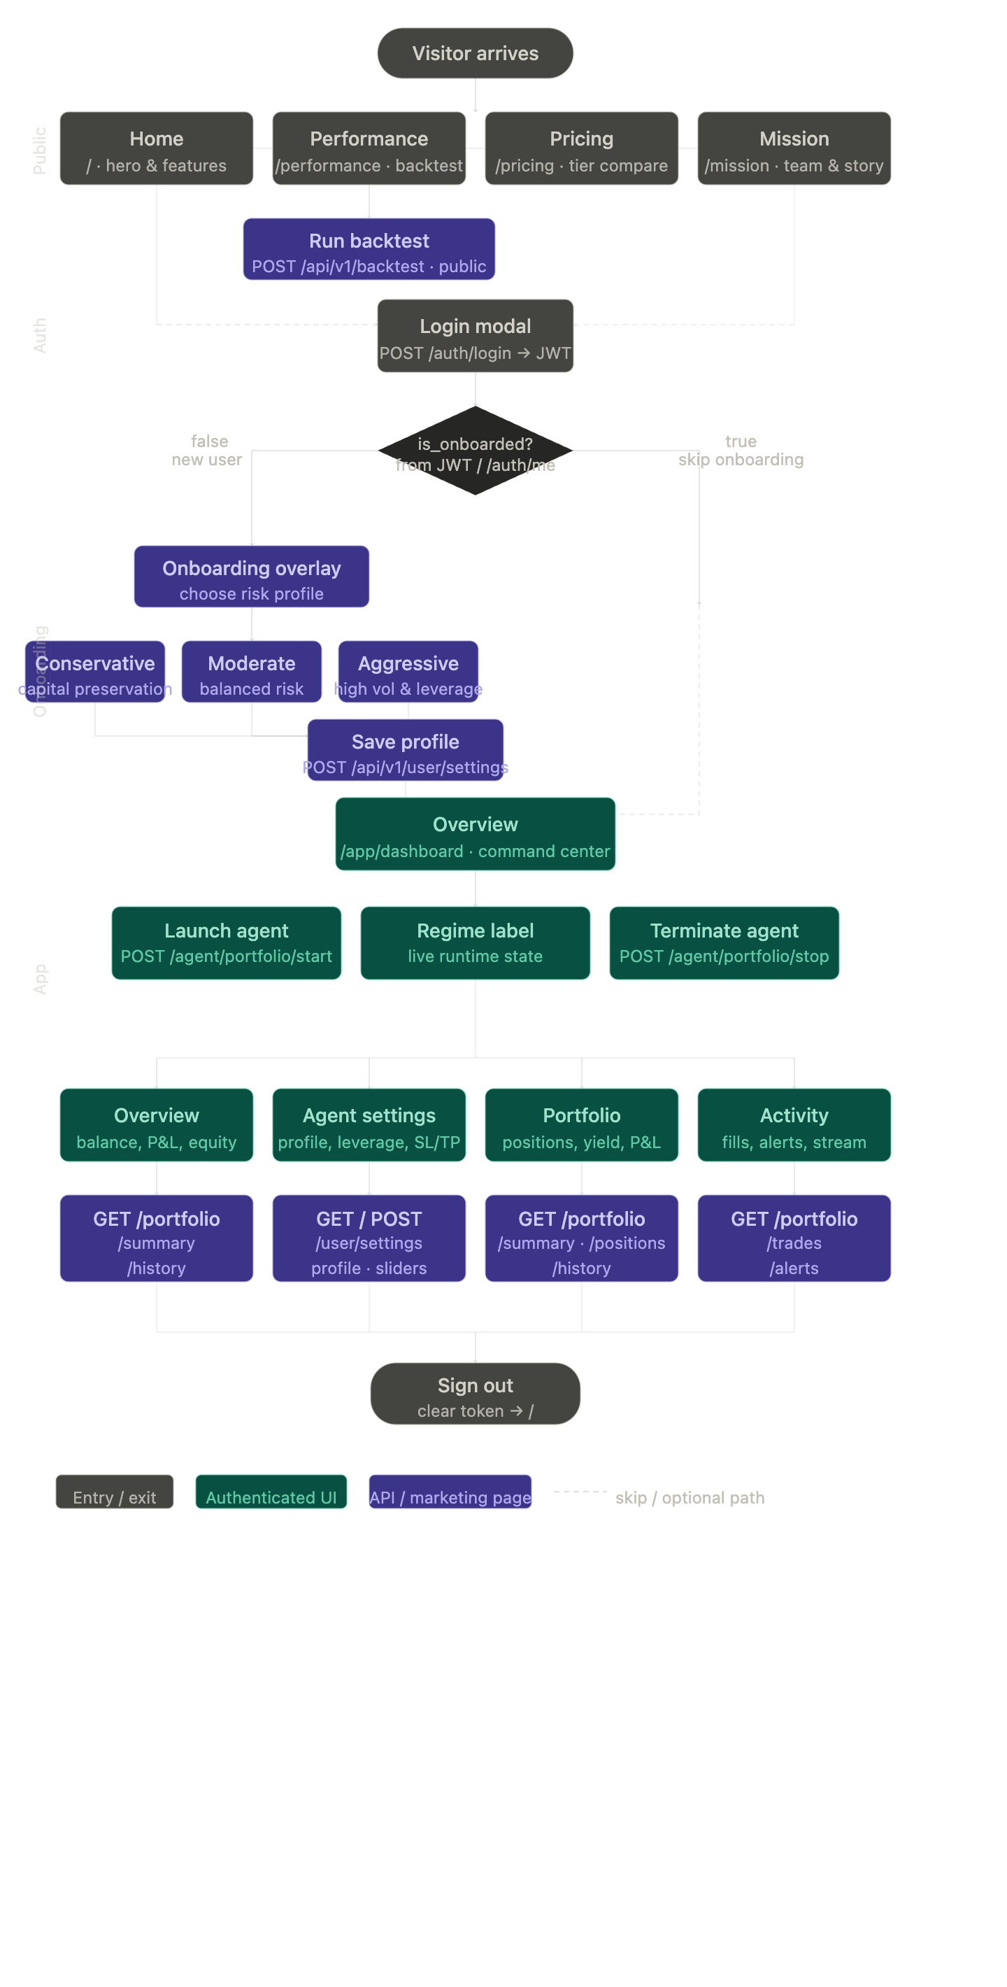

- Visitor arrives → browses the four public marketing pages (Home, Performance, Pricing, Mission), with Performance having its own live backtest call
- Login modal → User enters existing credentials. System sends POST /auth/login and receives a JWT.
- Branch A: If is_onboarded = true, skip directly to the Dashboard.
- Branch B: If is_onboarded = false, route to the Onboarding Overlay.
- Onboarding check → new users pick a risk profile and save it, returning users skip straight through
- Overview dashboard → launch/terminate agent actions sit directly off this node
- Four app sections (Overview, Agent Settings, Portfolio, Activity) shown as peers on the layout.
- Core Agent Controls (Main View):
- Strategy display is intentionally minimal on the dashboard. Users see their risk profile and asset universe size, while strategy choice and validation happen during onboarding or Agent Settings.
- Active/idle state is derived from GET /api/v1/agent/list, not local UI state, for authenticated users.
- Launch Agent: Starts the trading agent via POST /api/v1/agent/portfolio/start (submitting strategy_key, risk_profile, symbols, and timeframe).
- Terminate Agent: Stops the running agent via POST /api/v1/agent/portfolio/stop.
- Regime Label: Displays the current market regime directly from the agent's live runtime state.
- Agent Settings (/app/agent-settings):
- User interacts with risk profile cards and fine-tunes configurations using advanced sliders.
- System manages configurations via GET/POST /api/v1/user/settings.
- Portfolio (/app/portfolio):
- User views their asset composition via a donut chart, checks active listings in a positions table, and views their top-performing asset.
- System fetches data via:
  - GET /api/v1/user/portfolio/summary
  - GET /api/v1/user/portfolio/positions
  - GET /api/v1/user/portfolio/history
- Activity (/app/activity):
- User reviews live executions in a stream table and checks system alerts in a dedicated sidebar.
- System fetches data via:
  - GET /api/v1/user/portfolio/trades
  - GET /api/v1/user/portfolio/alerts
- Sign out → clears token and returns to home
Database Diagram
For our PostgreSQL database, the current migrated schema contains 23 logical application tables. The baseline runtime schema stores users, sessions, accounts, assets, agent settings, strategy configurations, single-symbol backtest history, agent runs, orders, fills, positions, cash ledger entries, portfolio snapshots, system alerts, and partitioned OHLCV bars. The alpha-foundation migration adds universes, universe members, portfolio backtest run storage, sleeve returns, model-artifact registry metadata, pair-candidate research, and strategy trial tracking. If physical partitions are counted separately, bars_y2024, bars_y2025, bars_y2026, and bars_default are additional SQL objects, but they are implementation partitions of bars rather than separate domain entities.
The latest portfolio-agent path stores one active catalog paper run per user as an agent_runs row with strategy_type PORTFOLIO_CATALOG. The concrete catalog key, selected universe, deployment metadata, execution mode, and HMM runtime regime state live inside agent_runs.parameters. Model binaries are not stored in Postgres: ml_model_artifacts keeps registry metadata and artifact_uri pointers, while the API loads promoted artifacts from the configured local/object-storage-backed cache.
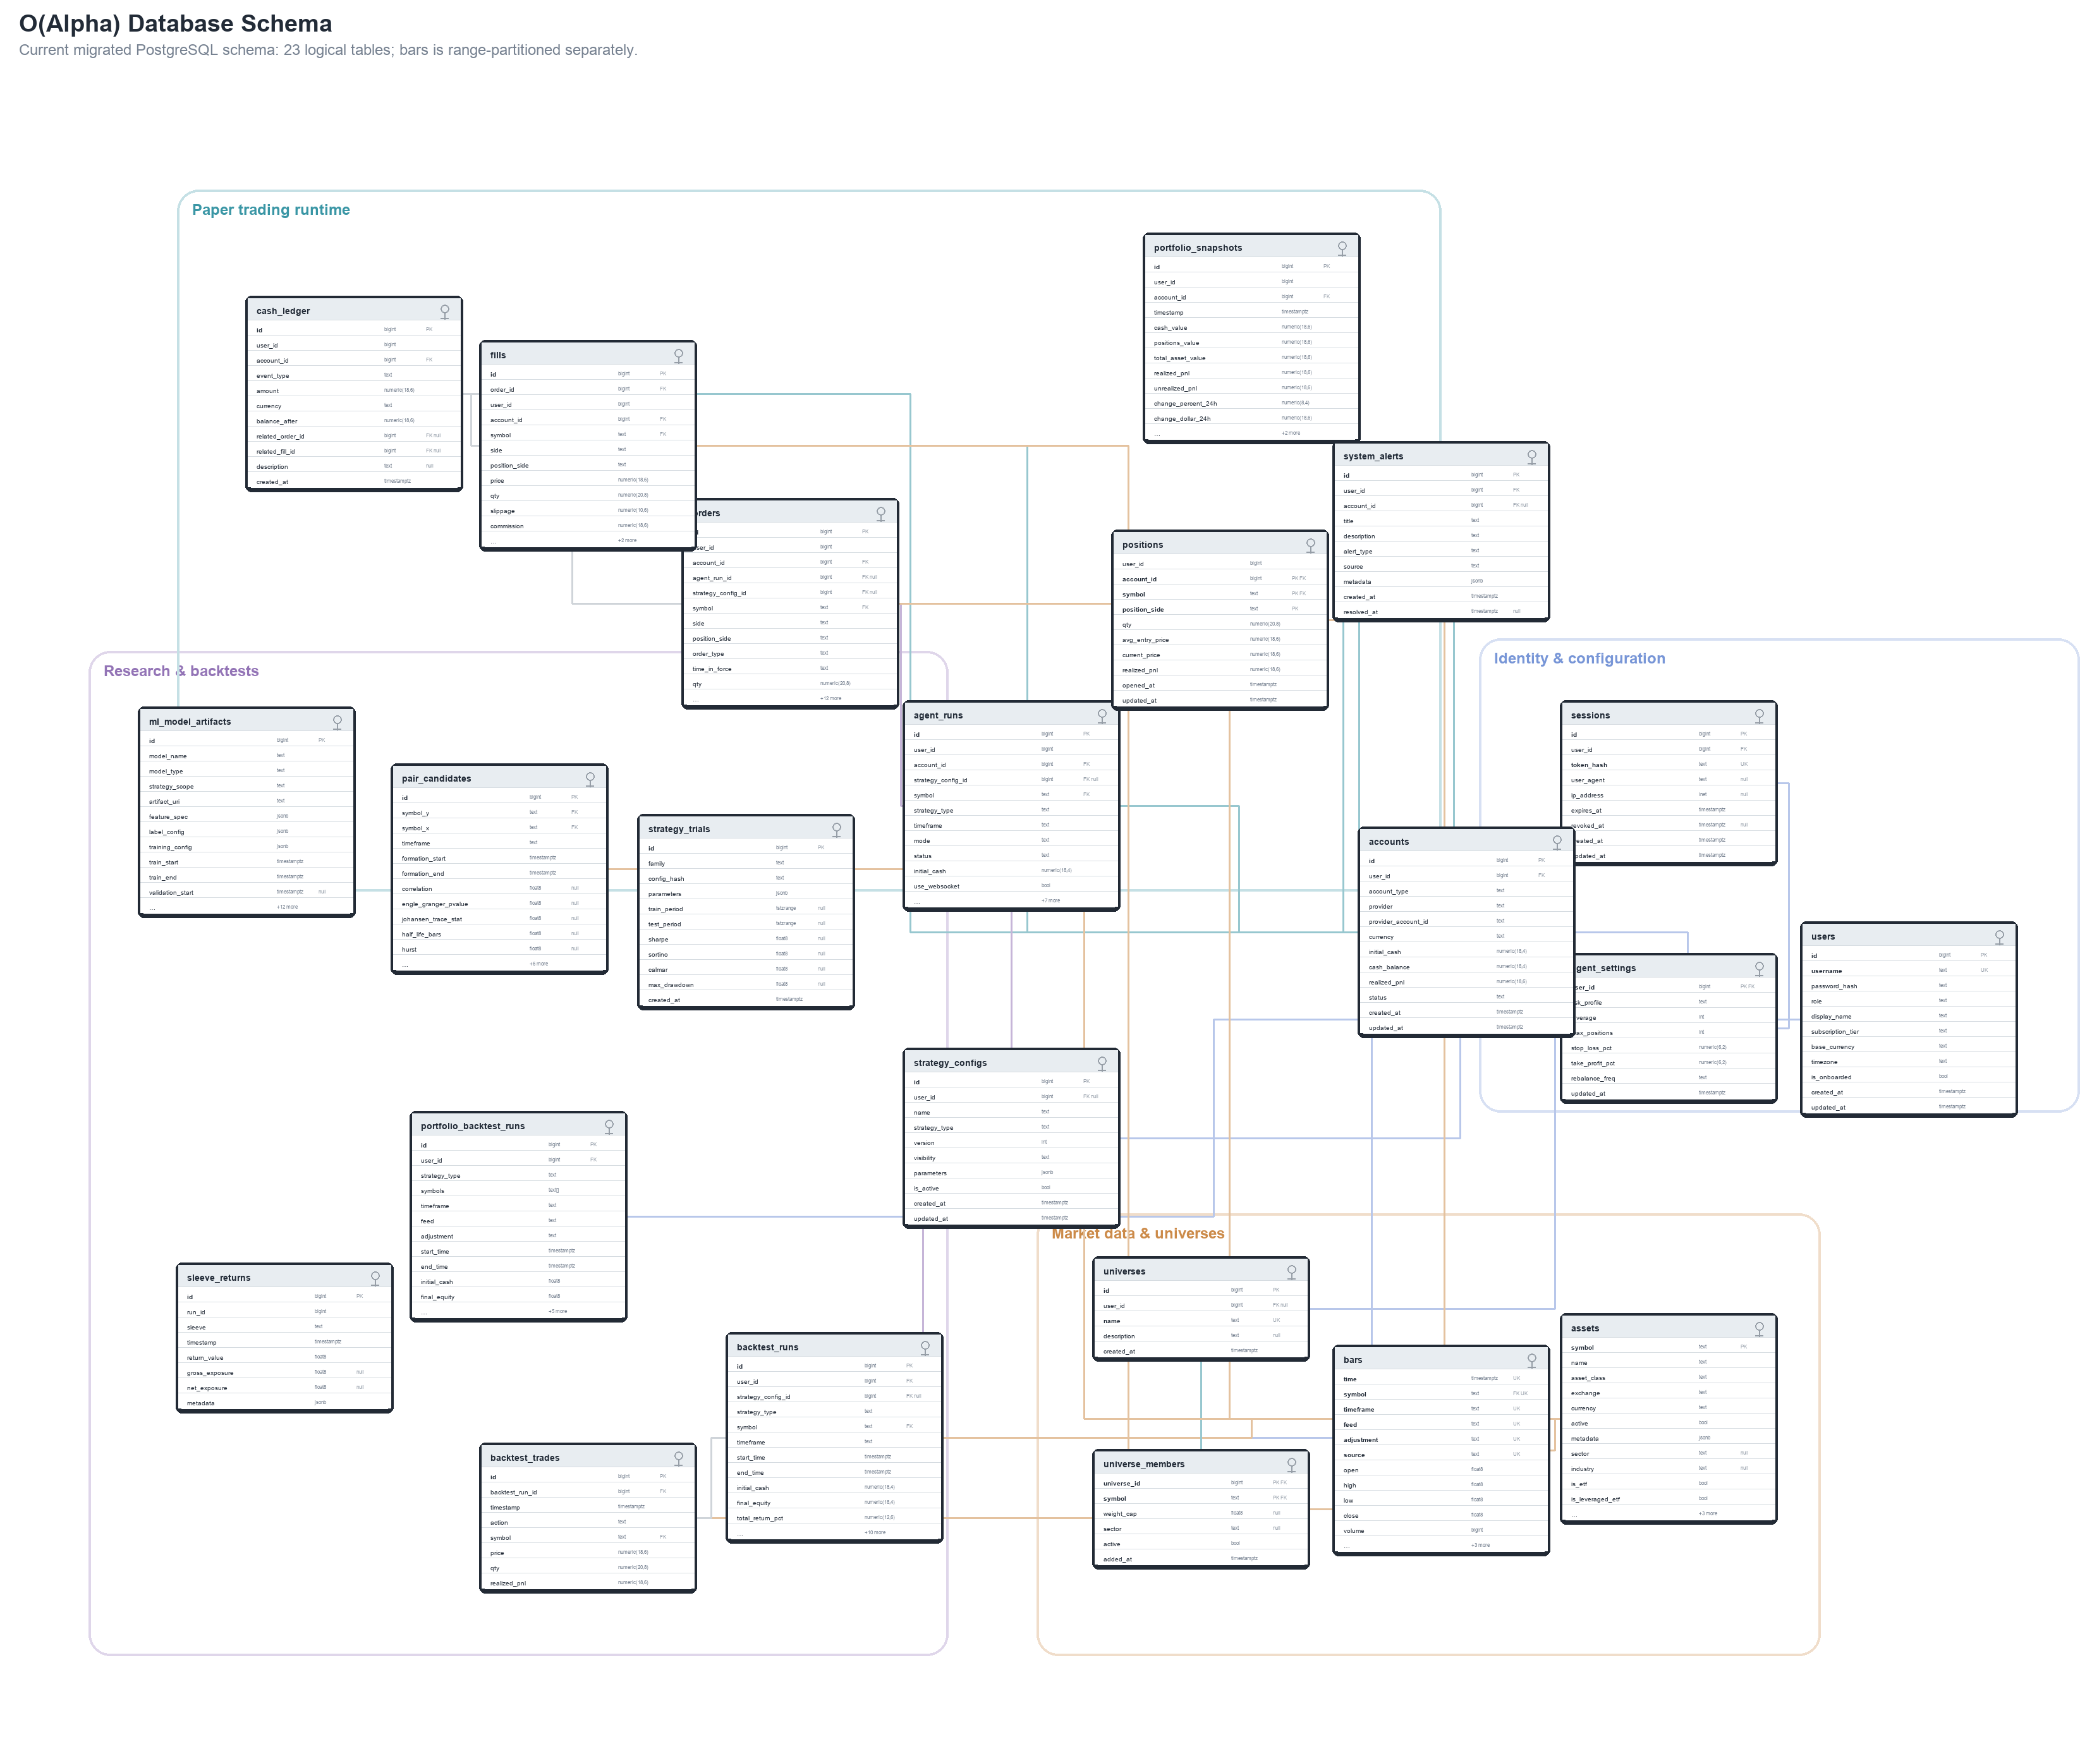

users
The table stores the basic details about each user. A row is entered when a new user registers, and is_onboarded flips to true only after the user has saved matching risk settings and accepted a catalog backtest. The role field distinguishes regular users from admins, subscription_tier records the user plan, and base_currency/timezone personalize display. password_hash stores only the hashed credential, and usernames remain unique on a case-insensitive basis through a lower(username) unique index.
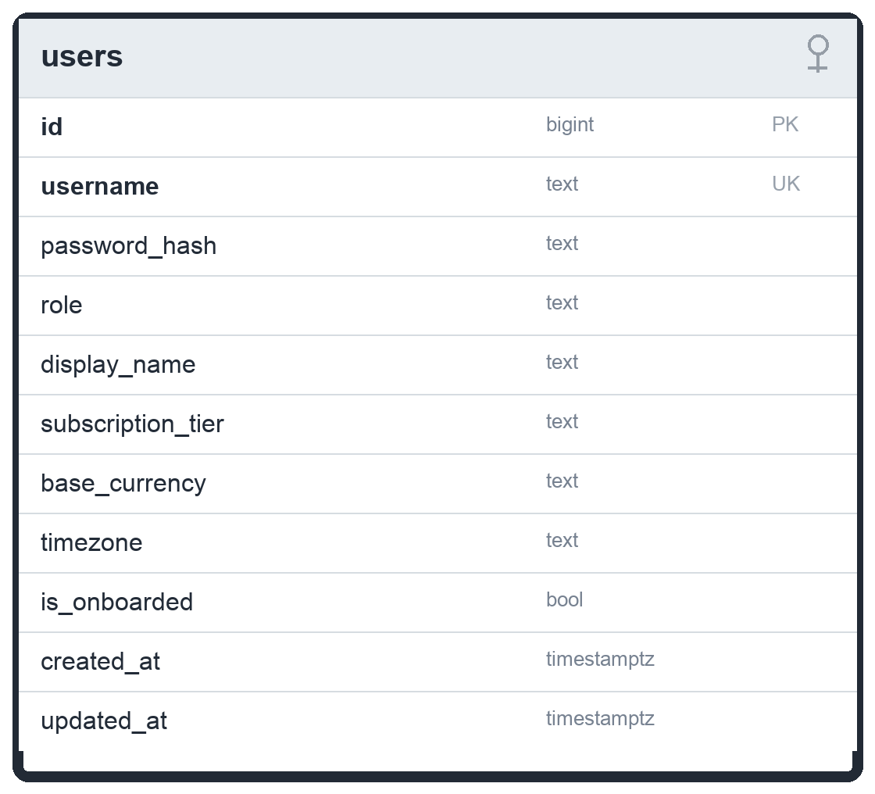

sessions
The table stores authentication sessions. token_hash holds the hashed session token so raw tokens are never persisted. expires_at controls natural expiry, revoked_at records explicit invalidation, and user_agent/ip_address retain client audit context. A session is active only while revoked_at is null and expires_at is still in the future.
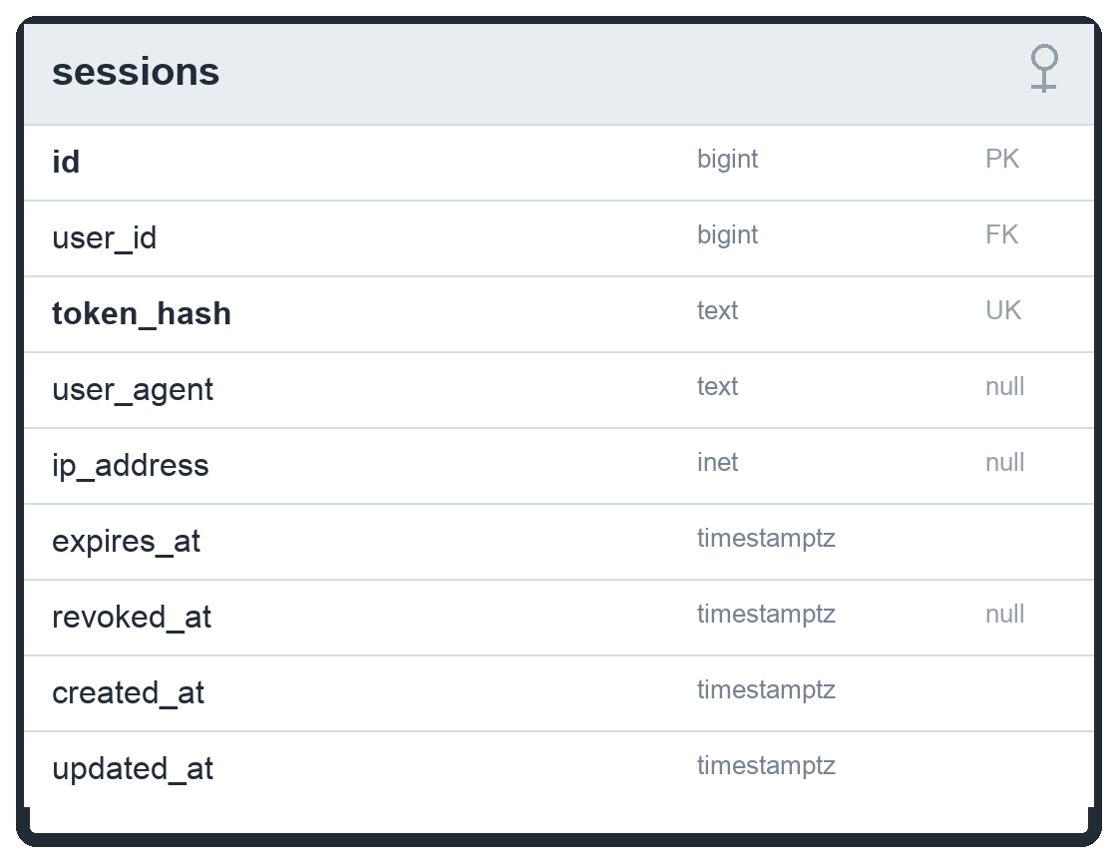

agent_settings
The table stores exactly one saved configuration row per user. It records risk_profile, leverage, max_positions, stop_loss_pct, take_profit_pct, and rebalance_freq. The current onboarding and settings flows validate strategy_key and backtest_accepted in the API request, but those two values are not columns in agent_settings; the selected portfolio catalog key is stored with active runs inside agent_runs.parameters.
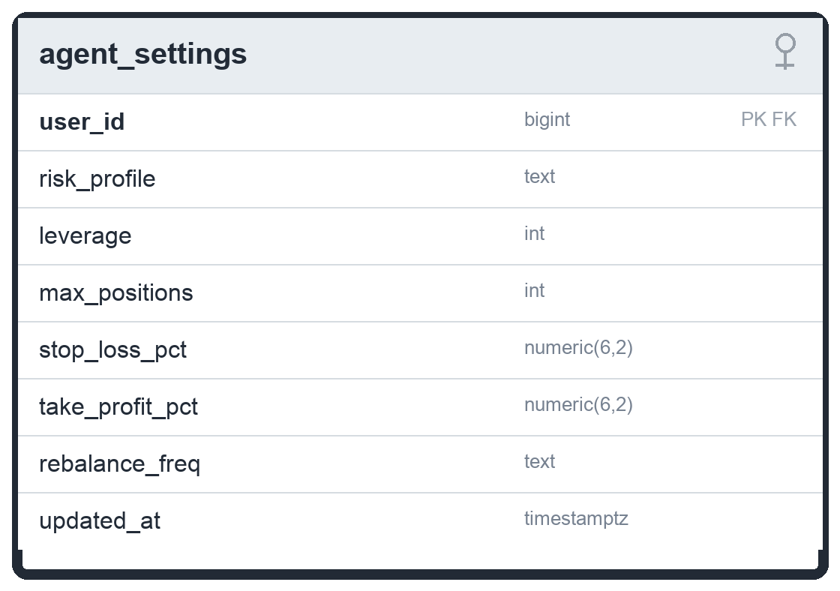

accounts
The table stores trading accounts owned by a user. The default application path uses an internal paper account seeded with initial_cash. cash_balance tracks available cash and realized_pnl accumulates closed-trade P&L. account_type separates paper and live-capable account records, status controls whether the account can trade, and the composite (id, user_id) relationship lets downstream trading tables enforce tenant isolation.
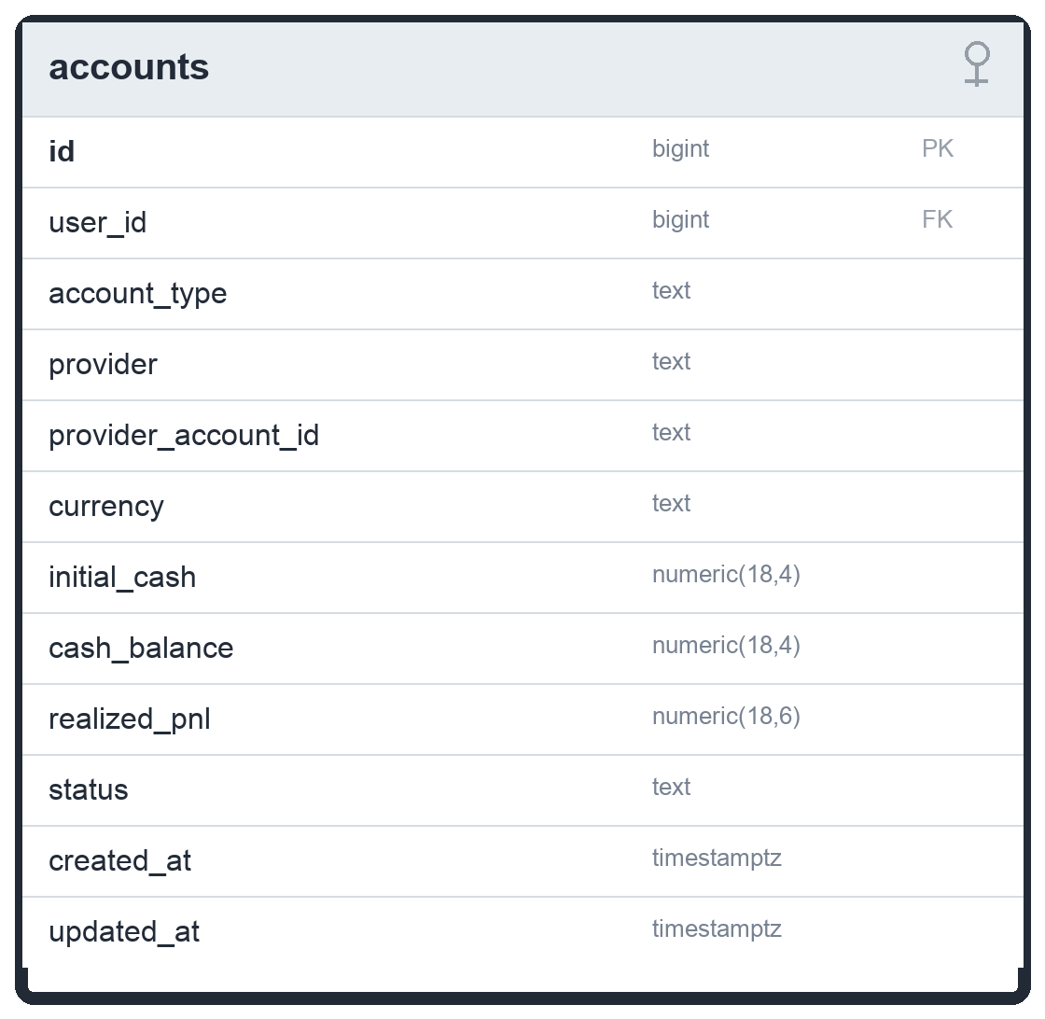

assets
The table is the instrument catalogue and uses symbol as the primary key. In addition to the original name, asset_class, exchange, currency, active flag, and metadata JSON, the current schema tracks sector, industry, and ETF classification flags: is_etf, is_leveraged_etf, and is_inverse_etf. These fields support universe construction, portfolio screens, and research filters without deleting historical data for inactive assets.
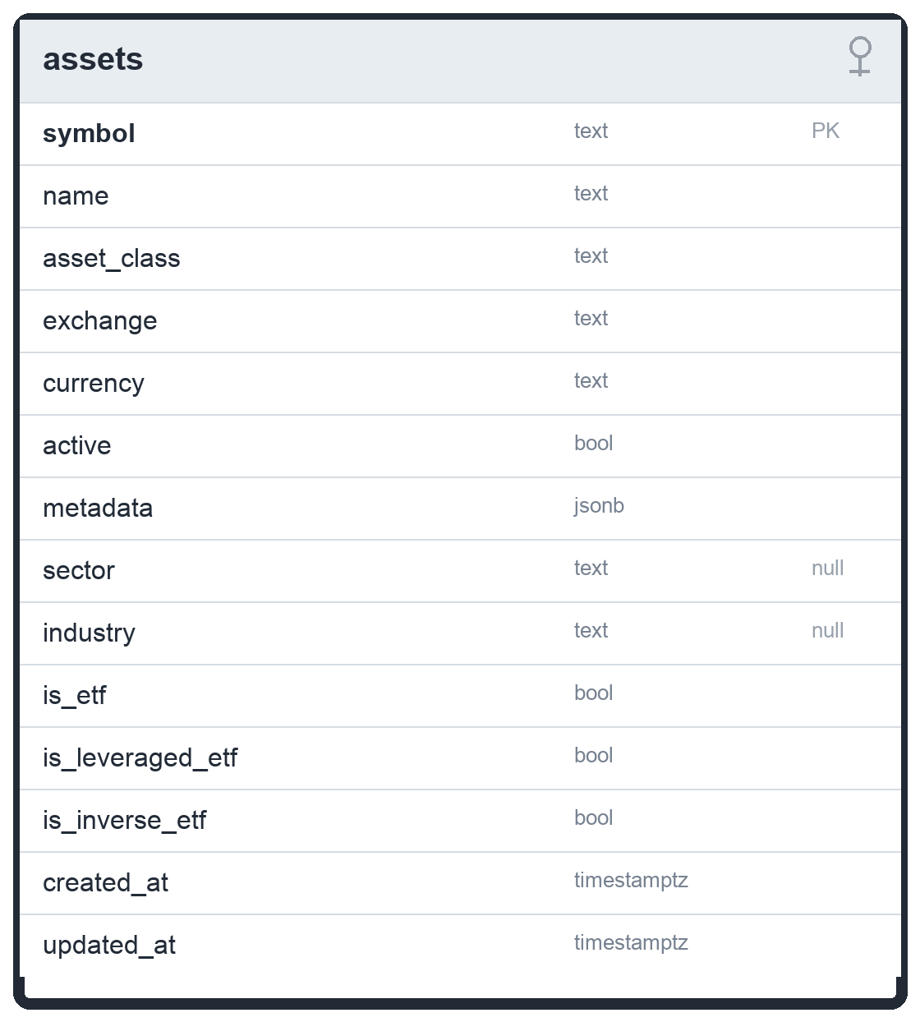

bars
The table stores OHLCV candles and is now keyed by dataset identity rather than only (time, symbol, timeframe). Each row includes feed, adjustment, and source so the system can distinguish raw Alpaca data from adjusted Yahoo/research datasets. A unique dataset index covers (time, symbol, timeframe, feed, adjustment, source), and the table remains range-partitioned by time through bars_y2024, bars_y2025, bars_y2026, and bars_default.
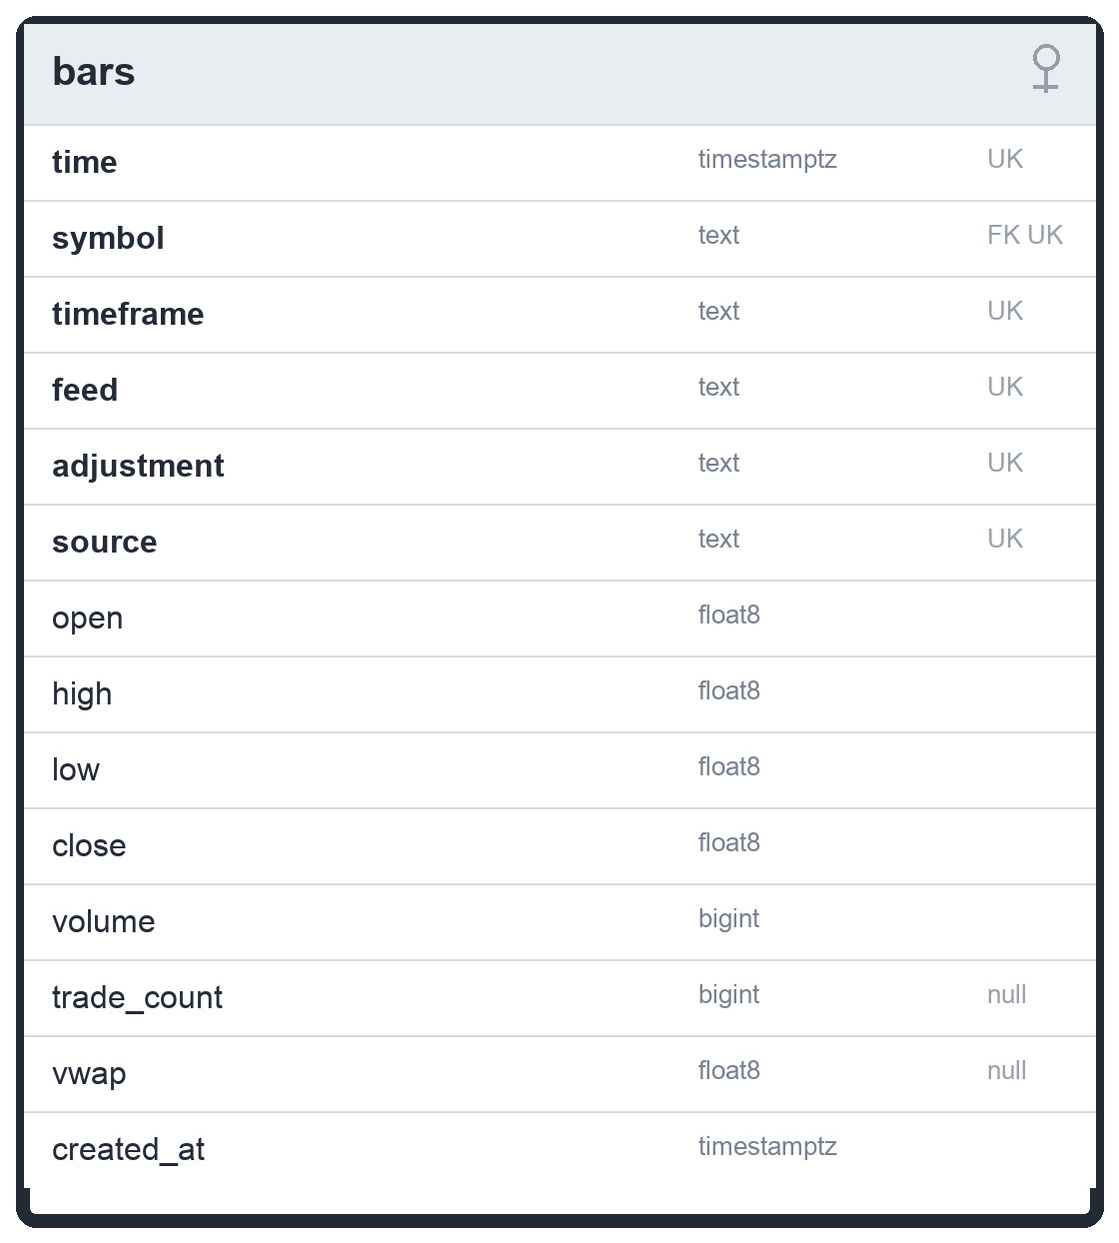

universes
The table stores named asset universes. A universe may be user-scoped through user_id or system-scoped when user_id is null. The name and optional description make curated sets such as the Yahoo100-style default universe addressable by the research and portfolio-agent layers.
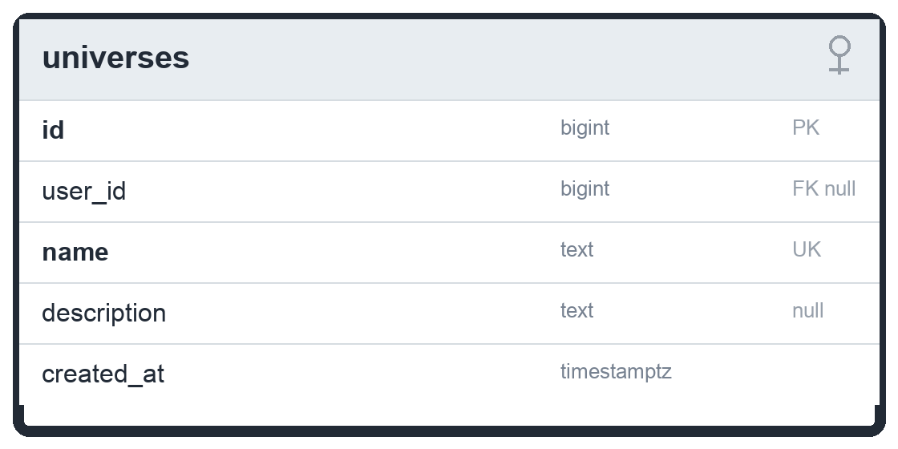

universe_members
The table stores the symbols that belong to each universe. The composite primary key (universe_id, symbol) prevents duplicate membership, while weight_cap, sector, active, and added_at provide portfolio-construction metadata and allow a universe to be curated over time without losing its membership history.
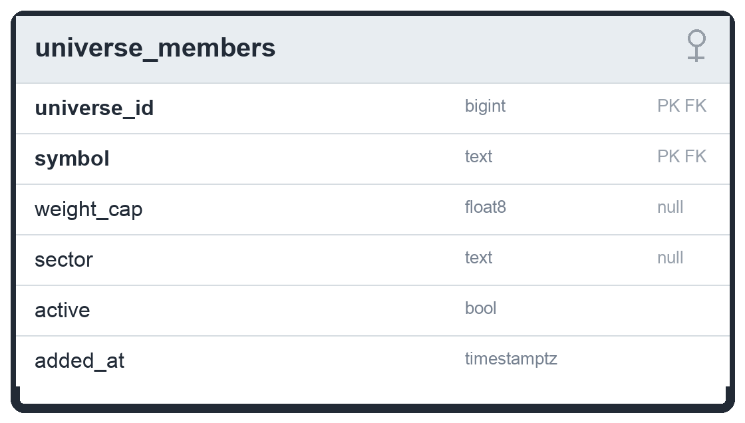

strategy_configs
The table stores named and versioned strategy configurations. It supports the expanded non-catalog strategy enum from the alpha-foundation migration: MA_CROSSOVER, KALMAN, REGIME_DETECTOR, PAIRS, HMM_ENSEMBLE, ML_META_LABEL, XSEC_MOMENTUM, KALMAN_COINTEGRATION, and MULTI_ENGINE_ENSEMBLE. PORTFOLIO_CATALOG is intentionally not part of this table constraint; catalog strategy selection is represented by strategy_key inside agent_runs.parameters.
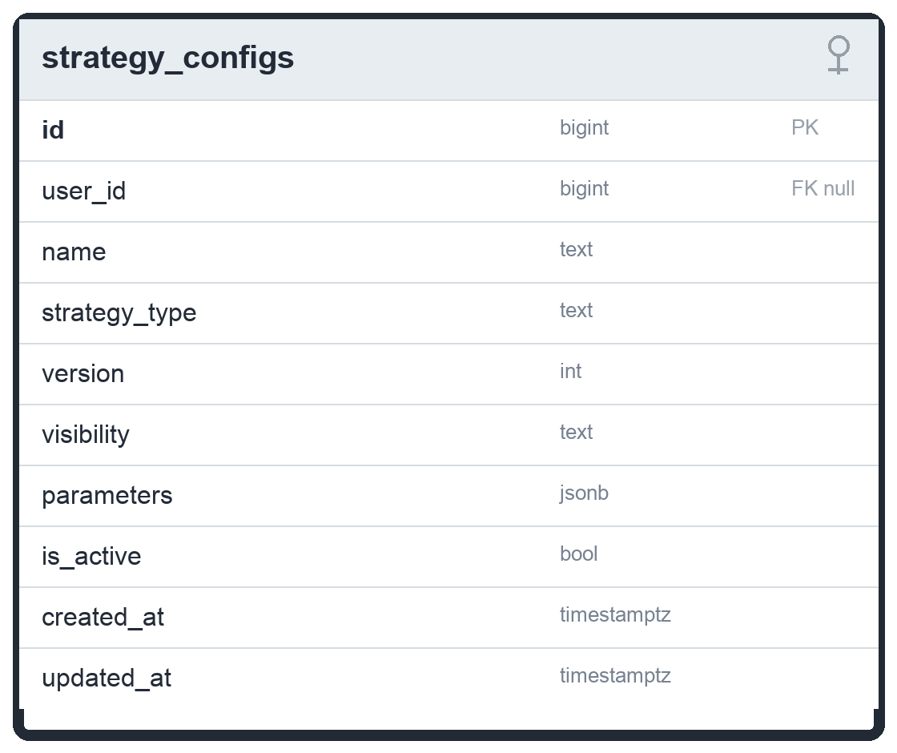

backtest_runs
The table provides schema support for persisted single-symbol or legacy backtest histories. It records the run window, symbol, timeframe, initial and final equity, headline metrics, parameters, diagnostics, and the equity curve JSON. The current portfolio streaming/onboarding backtest path returns results live from /api/v1/backtest/stream and does not persist PORTFOLIO_CATALOG runs into this constrained table.
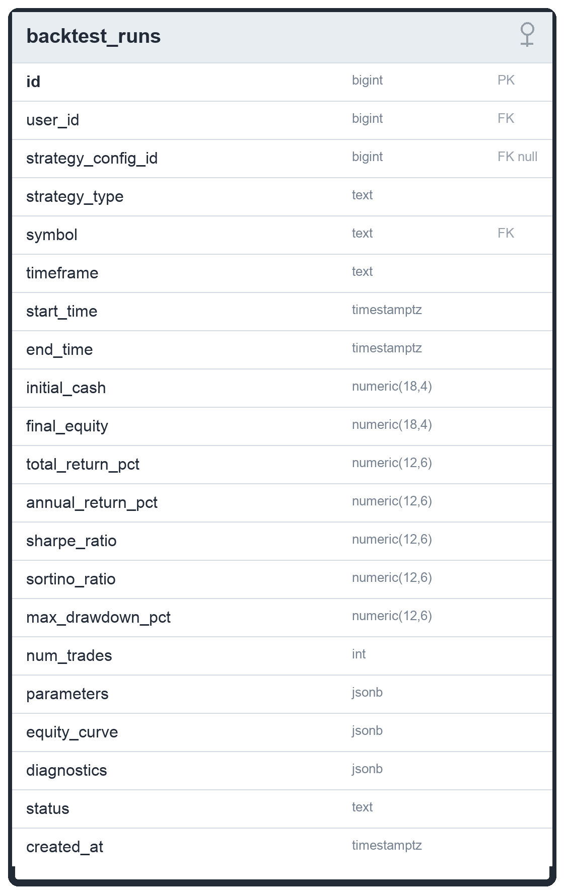

backtest_trades
The table provides schema support for trade-level backtest history linked to backtest_runs. It records timestamp, action, symbol, price, quantity, and realized P&L for simulated trades. In the current codebase, portfolio backtest trades are returned in the portfolio result payload; this table should be described as persistence capacity rather than the live source of onboarding chart data unless the save path is reconnected.
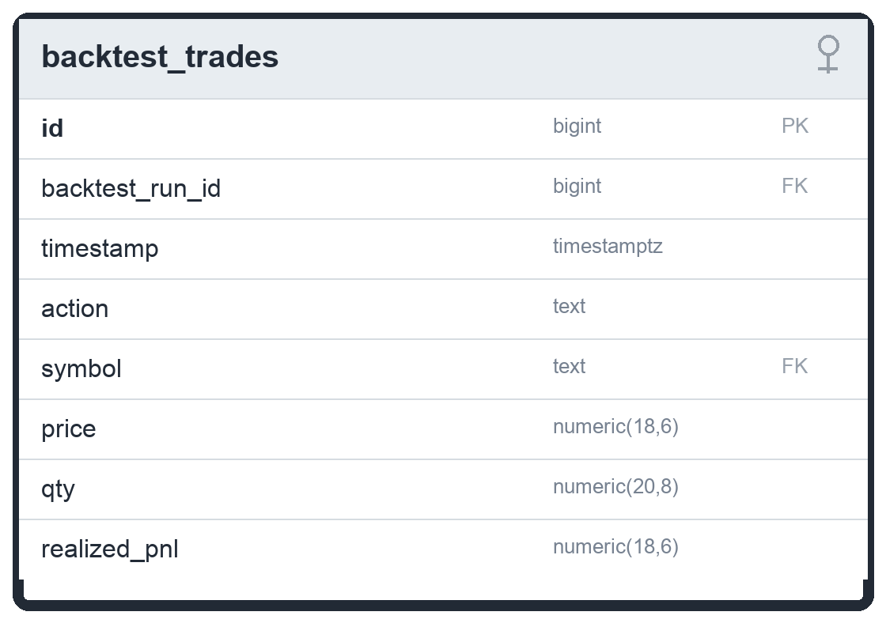

portfolio_backtest_runs
The table is the newer schema for multi-symbol portfolio backtest results. It stores symbols, timeframe, feed, adjustment, run window, initial/final equity, metrics, parameters, equity_curve, and trades as JSON. It is the correct destination for persisted PORTFOLIO_CATALOG/XSEC/Kalman-pair portfolio histories when persistence is wired, while today the onboarding graph primarily consumes streamed NDJSON results.
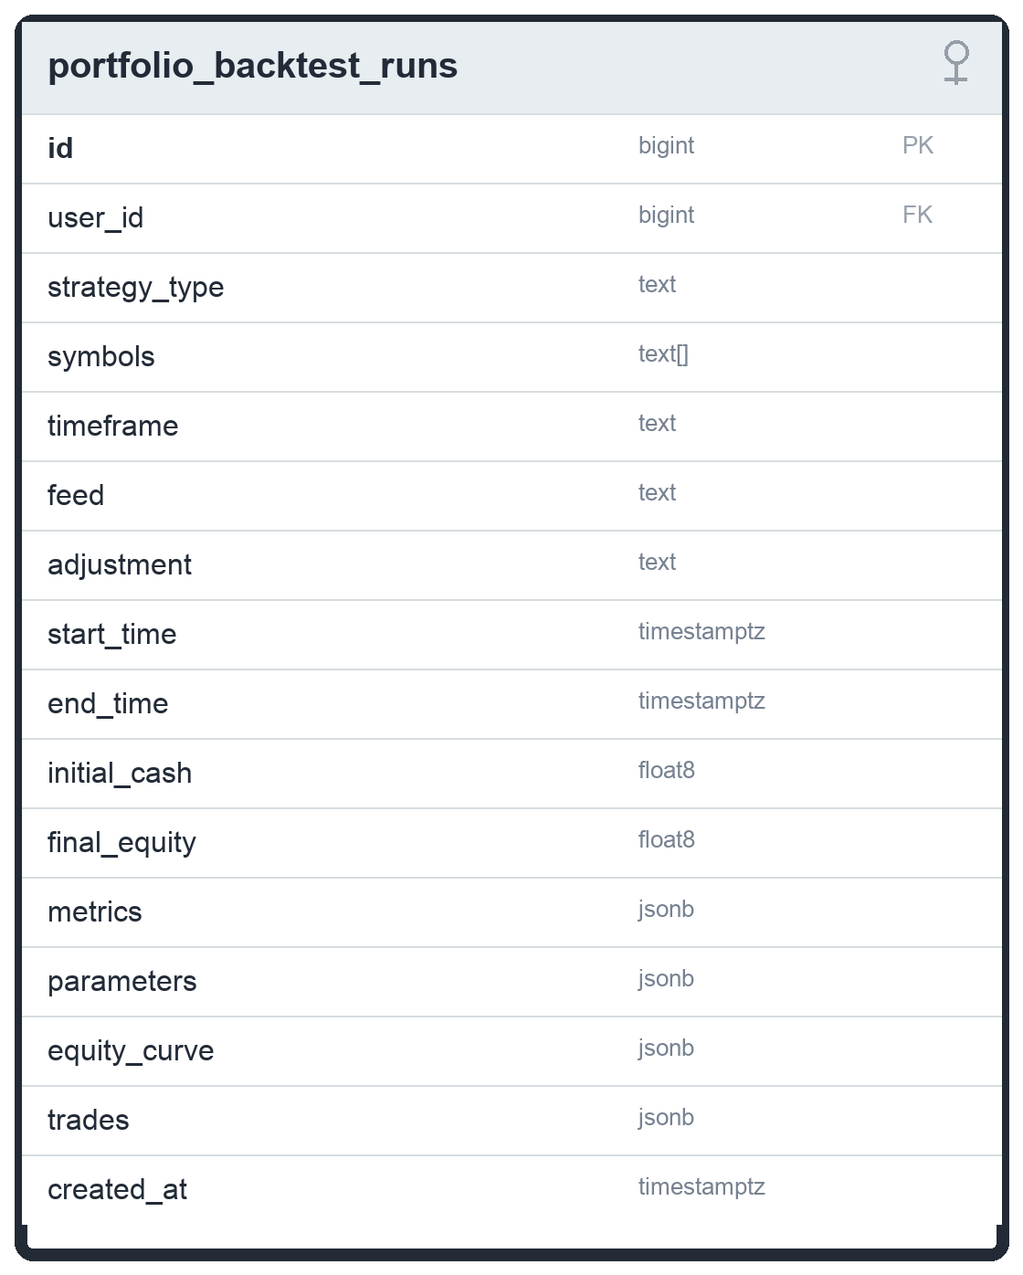

sleeve_returns
The table stores per-sleeve return and exposure series for portfolio research. run_id identifies the logical run, sleeve names the component strategy or allocation sleeve, timestamp orders the series, and gross_exposure/net_exposure provide diagnostics for ensemble or active-sleeve analysis. metadata keeps additional research annotations as JSON.
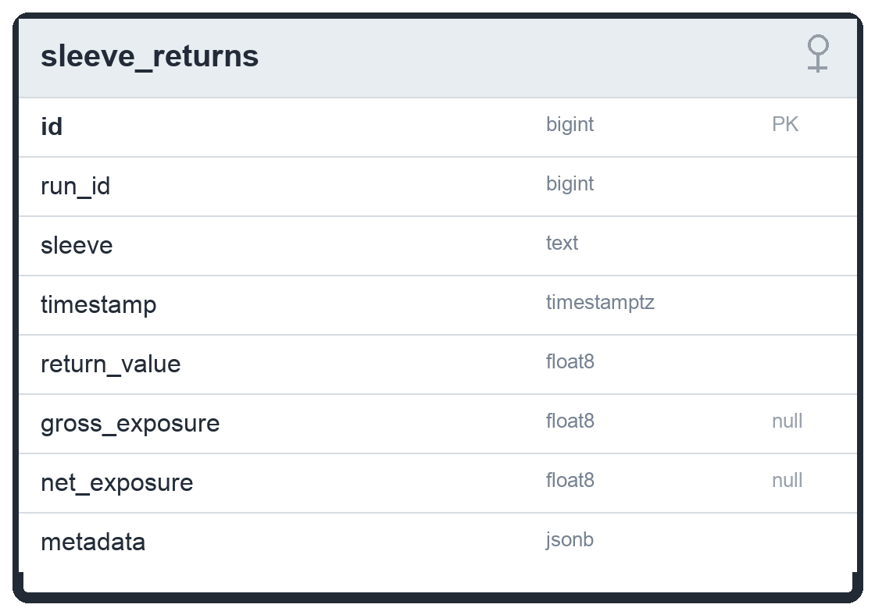

ml_model_artifacts
The table is a registry for model metadata, not a blob store. It records model_name, model_type, strategy_scope, artifact_uri, feature/label/training specs, train and validation windows, validation metrics such as AUC/logloss/Sharpe/DSR/PBO, leaves-parity checks, and status. The promoted artifact bytes live in local/object storage and are loaded by the API from the configured artifact root.
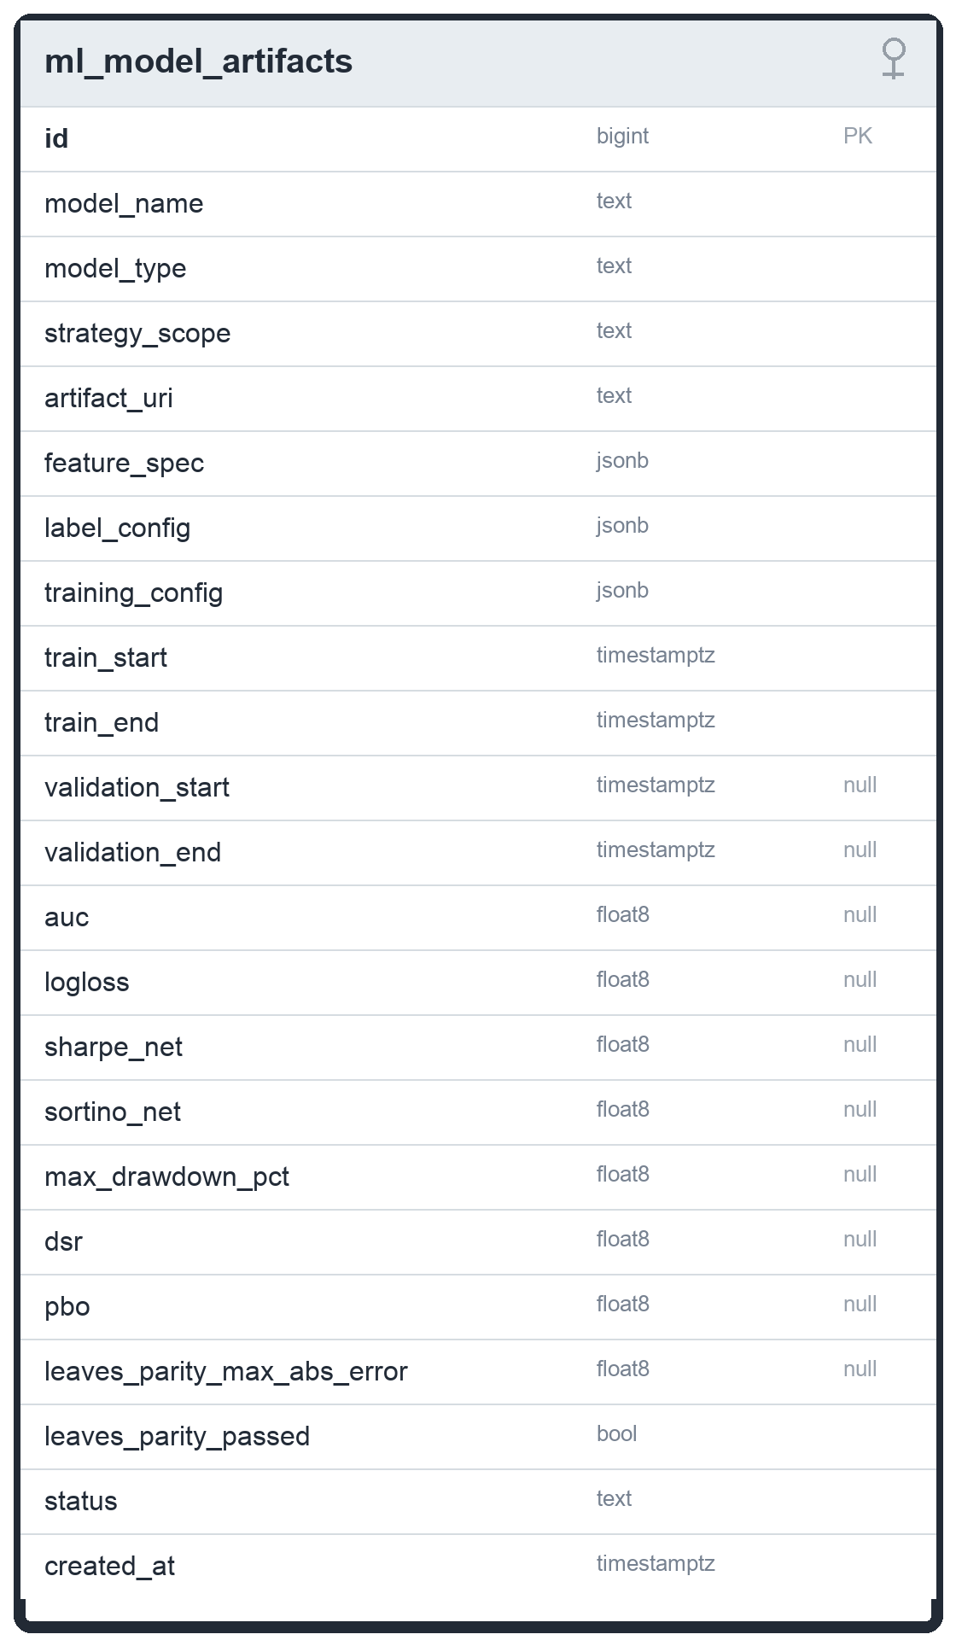

pair_candidates
The table stores Kalman/cointegration pair research candidates. symbol_y and symbol_x reference assets, formation_start and formation_end define the research window, and statistical diagnostics such as correlation, Engle-Granger p-value, Johansen trace statistic, half-life, Hurst, and estimated trading cost support offline approval. approved/status gate whether a pair can graduate from research.
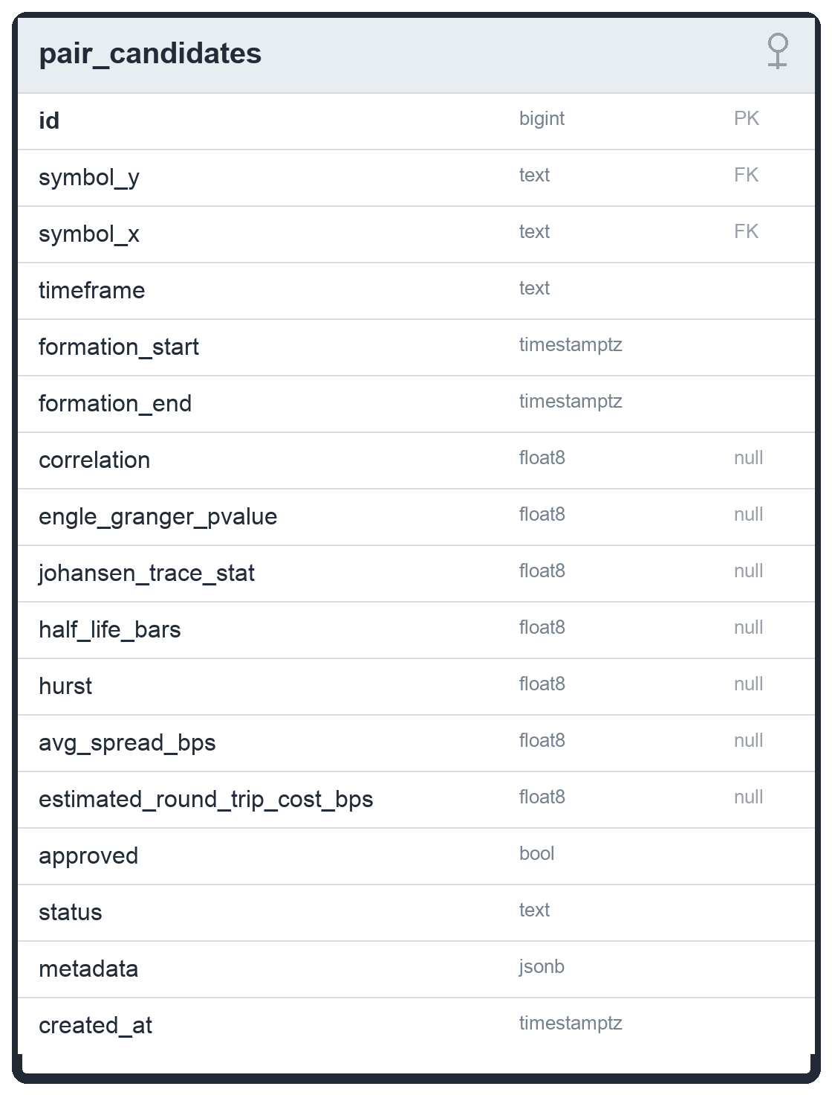

strategy_trials
The table stores research trial metadata for alpha-search experiments. family and config_hash identify the candidate family/configuration, parameters captures the tested settings, train_period and test_period preserve the walk-forward window, and sharpe/sortino/calmar/max_drawdown store summary validation metrics for comparison across trials.
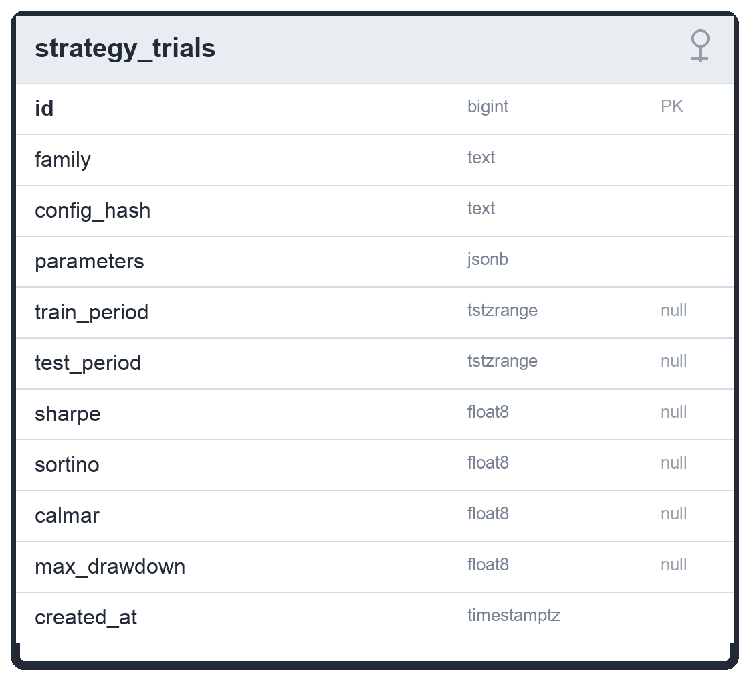

agent_runs
The table represents a paper or live-capable automated agent session. The portfolio-agent path creates PORTFOLIO_CATALOG rows, uses symbol as the benchmark symbol, and stores the concrete strategy_key, selected symbols, paper_only/deployment metadata, execution_mode, and runtime_state inside parameters. status moves through starting, running, stopping, stopped, or failed, while last_heartbeat_at, stopped_at, and stop_reason make running-state and restart reconciliation auditable.
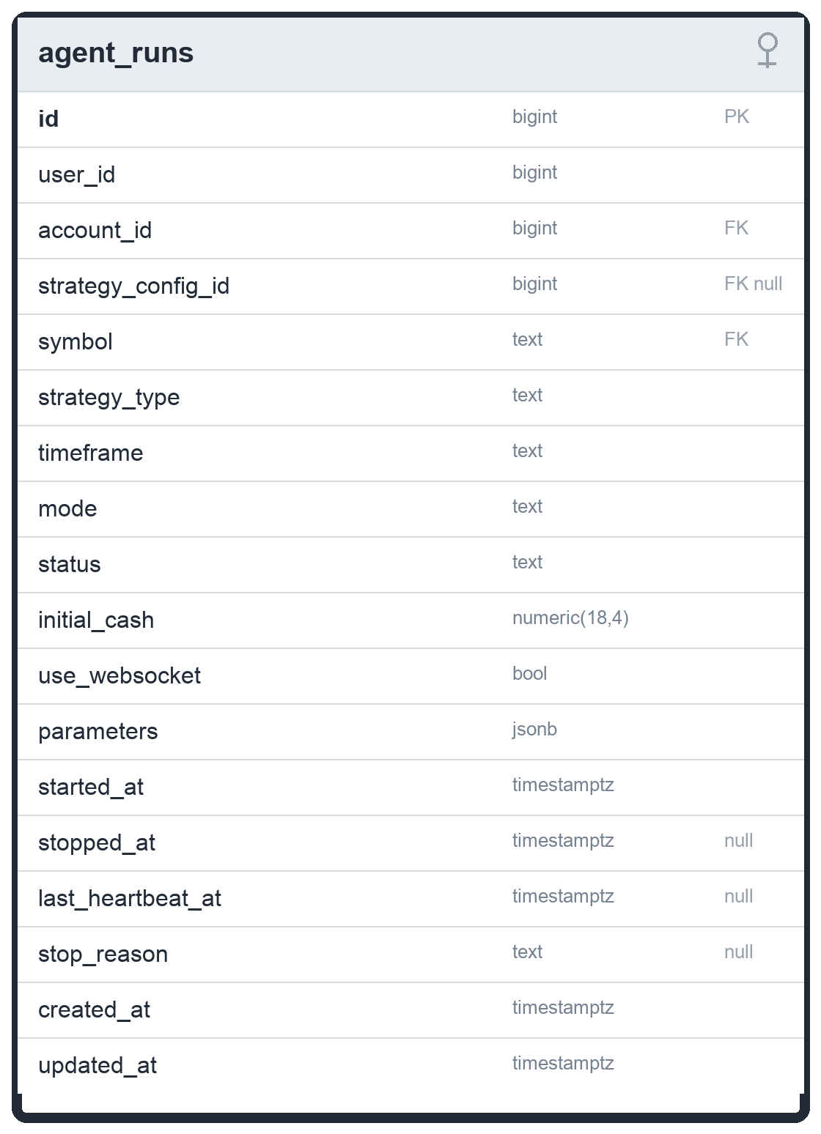

orders
The table stores every submitted paper/broker order. It captures side, position_side, order_type, time_in_force, quantity, optional limit/stop prices, provider identifiers, metadata, and lifecycle timestamps. client_order_id is unique when present and is used by the DB execution router as an idempotency key so repeated portfolio-agent evaluations do not double-fill the same intended trade.
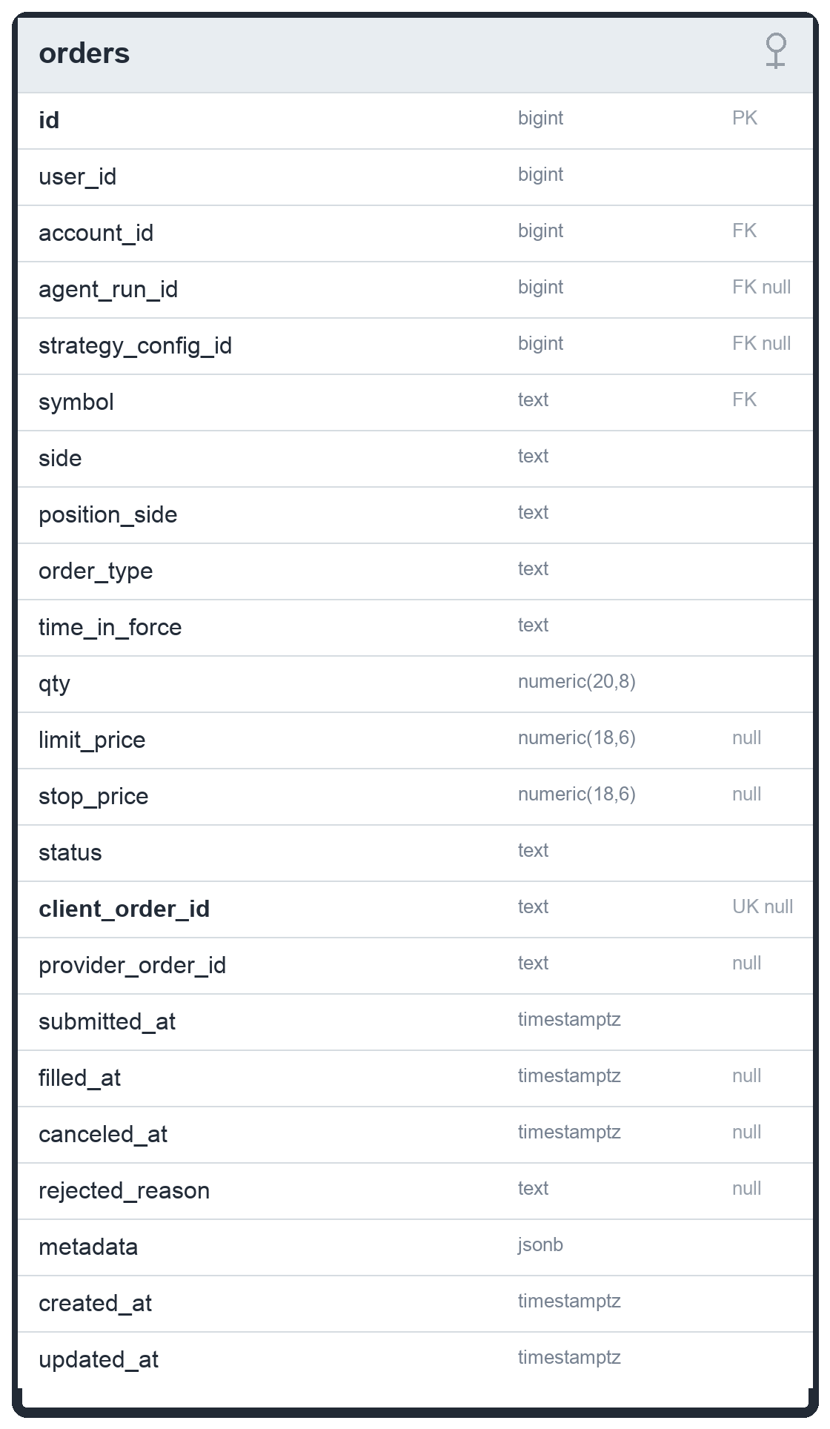

fills
The table stores executions against orders. Each fill links to its parent order and account, records symbol, side, position_side, executed price, quantity, slippage, commission, liquidity, and filled_at. The current DB execution router writes filled paper orders and fills together so the activity screen can read a canonical execution stream.
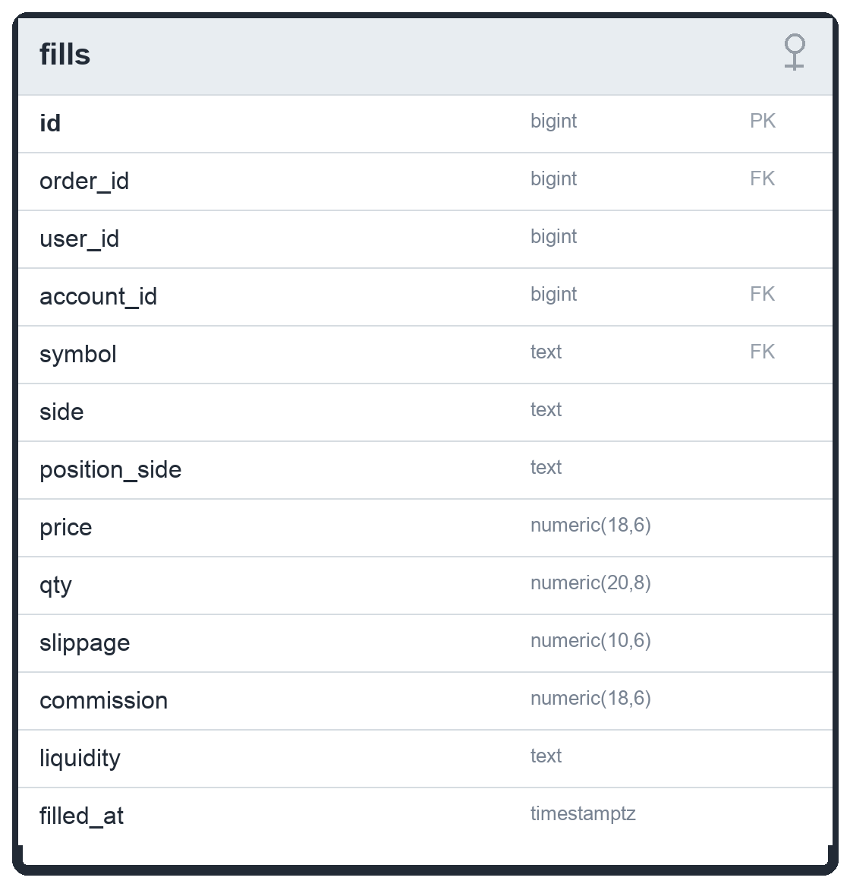

positions
The table stores the current open holdings of an account and is keyed on (account_id, symbol, position_side), allowing at most one long and one short row per symbol/account. It tracks quantity, average entry, current marked price, realized P&L, and timestamps. The portfolio dashboard allocation reads this table through /api/v1/user/portfolio/positions.
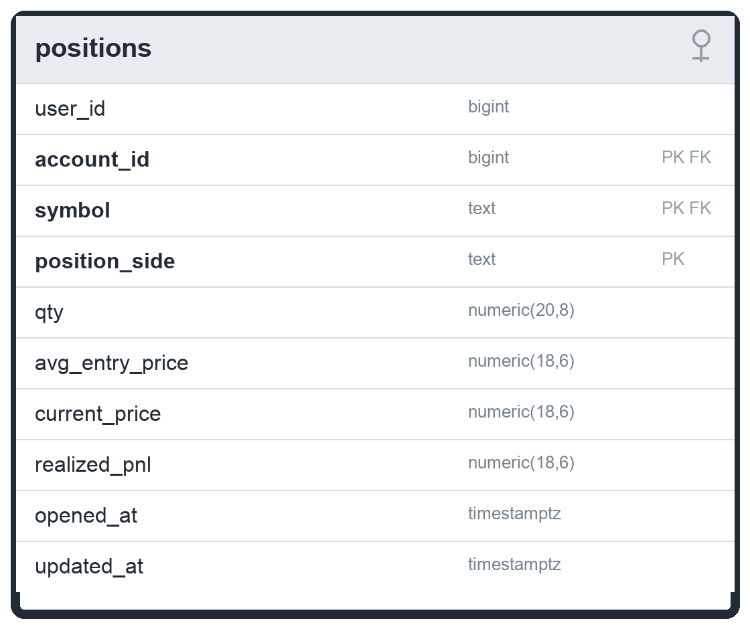

cash_ledger
The table is an append-only cash audit trail. It records deposits, withdrawals, buy/sell trade cash movements, commissions, and adjustments with signed amount and balance_after. Related order/fill links make each cash movement traceable back to the execution event that caused it.
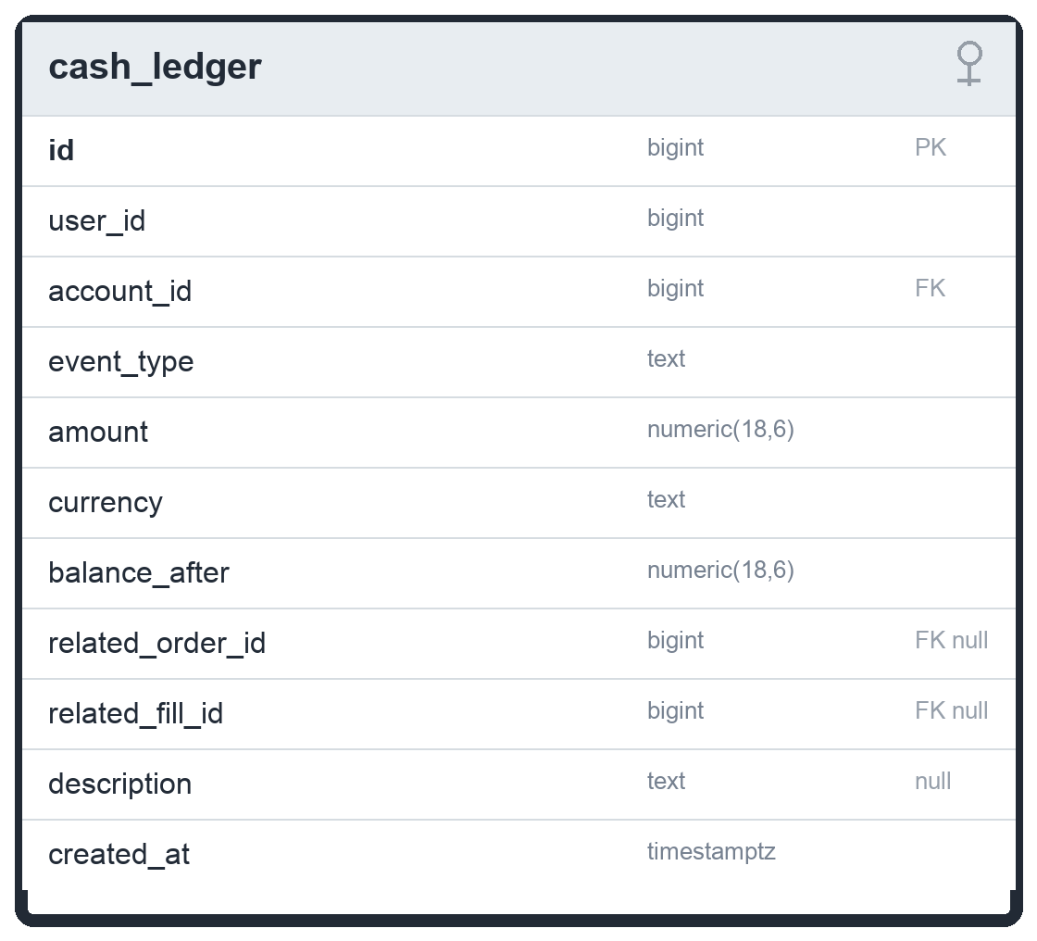

portfolio_snapshots
The table stores account valuation snapshots written by the portfolio repository/worker after evaluations and mark-to-market updates. It captures cash value, positions value, total asset value, realized/unrealized P&L, 24-hour change values, and target progress. estimated_annual_yield exists in the schema but is currently written as 0 by SavePortfolioSnapshot, so it should not be marketed as a live computed metric yet.
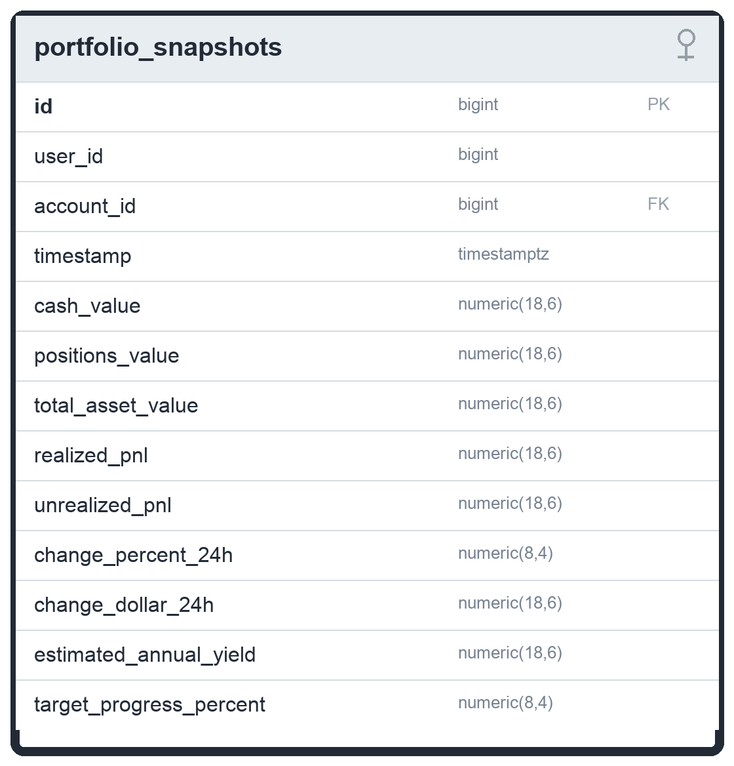

system_alerts
The table stores user-visible notifications. Portfolio-agent actions write alerts for rebalance executions and user-requested stops, with source and metadata identifying where the alert came from. alert_type is constrained to INFO, WARNING, or CRITICAL, and resolved_at distinguishes open alerts from cleared ones.
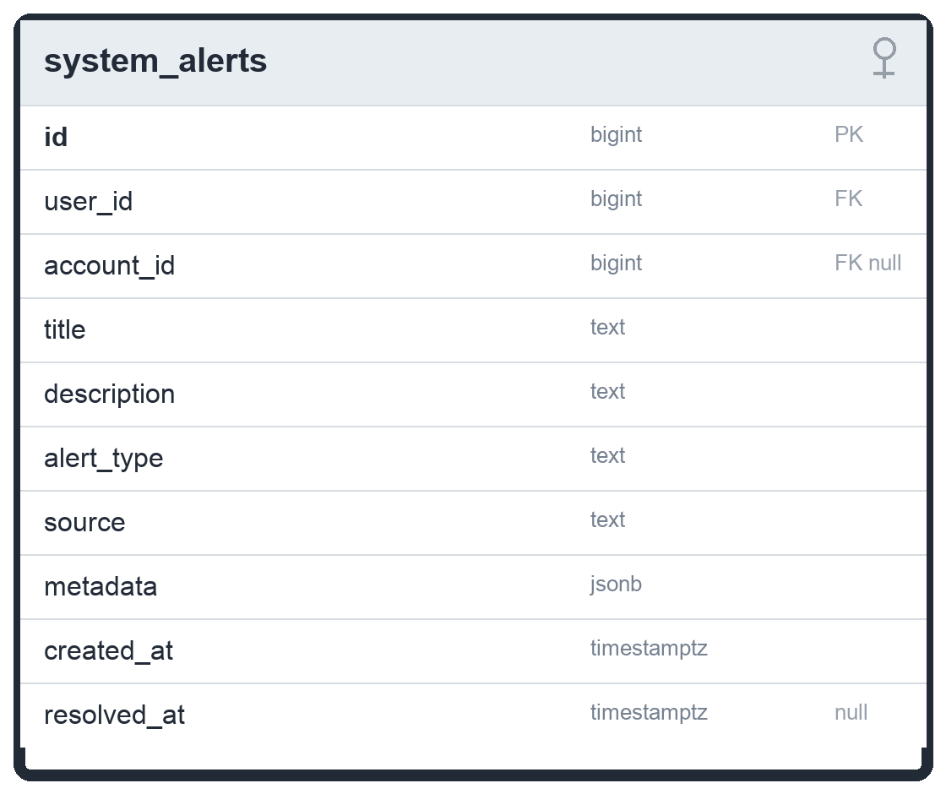

Technical Overview
This section separates the current codebase into two strategy contracts. backtest.Strategy powers single-symbol MA/Kalman/HMM/ML-meta-label simulations and legacy symbol agents; backtest.PortfolioStrategy powers multi-symbol catalog backtests and the main daily-bar paper-trading agent. API exposure below reflects backend/internal/api/router.go and the current handler implementations.

Single-symbol Kalman filter and state-space model
The engine extracts a smoothed “true price” from a noisy close-price feed by running a discrete, scalar, linear state-space filter. Let ${\hat{x}}_{t}$ be the estimated latent true price at bar $t$ and let $P_{t}$ be the scalar estimation error covariance. The implementation assumes a random-walk price process with no control input, unit state transition, and unit observation:
$$x_{t}=x_{t-1}+w_{t}, z_{t}=x_{t}+v_{t},$$
with process noise and measurement noise . The two variances are the only tunable parameters: (the process-noise variance, exposed as q_noise) governs how quickly the filter adapts to genuine price movement, and (the measurement-noise variance, exposed as r_noise) governs how aggressively short-term market noise is rejected. Both are configurable per run through BacktestRequest and the legacy symbol-agent request payload; the landing performance page exposes them in its Kalman controls.

Prediction (time update)
With unit state transition and no control input, the projection of state and the extrapolation of error covariance reduce to:
$${\hat{x}}_{t∣t-1}={\hat{x}}_{t-1∣t-1}$$
$$P_{t∣t-1}=P_{t-1∣t-1}+Q$$

Correction (measurement update)
On receipt of the raw close $z_{t}$, the filter computes the Kalman gain $K_{t}$, blends the prediction with the measurement, and contracts the error covariance:
$$K_{t}=\frac{P_{t∣t-1}}{P_{t∣t-1}+R}$$
$${\hat{x}}_{t∣t}={\hat{x}}_{t∣t-1}+K_{t} \left(z_{t}-{\hat{x}}_{t∣t-1}\right)$$
$$P_{t∣t}=\left(1-K_{t}\right) P_{t∣t-1}$$
The gain $K_{t}∈\left(0,1\right)$ interpolates between trusting the prior ($K_{t}→0$ when $R$ dominates) and trusting the latest print ($K_{t}→1$ when $P_{t∣t-1}$ dominates).

Initialization and steady state
The filter is seeded on its first observation rather than from a prior guess:
$${\hat{x}}_{0∣0}=z_{0}, P_{0∣0}=1.$$
Because $Q$ and $R$ are constant, $P_{t}$ converges to a fixed point and $K_{t}$ approaches a constant steady-state gain; the filter then behaves like an exponential moving average whose smoothing factor is set by the ratio $Q/R$. Default configuration: $Q=0.01$, $R=0.5$.

Kalman mean-reversion signal (Z-score)

Residual
Execution signals are derived from the statistical residual between the observed price and the filter estimate. The deployed code evaluates the residual against the posterior (filtered) estimate ${\hat{x}}_{t∣t}$ — that is, it calls the filter update first and then measures the gap:
$$e_{t}=z_{t}-{\hat{x}}_{t∣t}.$$
Implementation note. This is the filtered residual, not the classical one-step innovation $z_{t}-{\hat{x}}_{t∣t-1}$. The distinction matters for tuning: because the posterior has already absorbed part of $z_{t}$, the residual magnitude scales with $\left(1-K_{t}\right)$ relative to the innovation. If a future revision wants the canonical innovation, capture the residual before the update step.

Rolling dispersion
The residuals are accumulated in a sliding window of the most recent $W$ observations (lookbackWindow, default $W=20$). Over that window the engine computes the sample standard deviation, using Bessel’s correction:
$$σ_{W}=\sqrt{\frac{1}{W-1}\sum_{i=t-W+1}^{t}{(}e_{i}-\overset{‾}{e})^{2}}, \overset{‾}{e}=\frac{1}{W}\sum_{i=t-W+1}^{t}{e_{i}}.$$
The window mean $\overset{‾}{e}$ is used only to estimate dispersion; the score itself (below) divides the raw residual by $σ_{W}$, since the residual stream is expected to be approximately zero-mean.

Z-score and decision rule
The standardized deviation that triggers entries and exits is:
$$Z_{t}=\frac{e_{t}}{σ_{W}}.$$
Signals are assigned deterministically against a symmetric threshold $Z_{\text{thr}}$ (z_threshold, default $2.0$):
$${\text{Signal}}_{t}=\left\{\begin{matrix}\text{BUY}, & Z_{t}<-Z_{\text{thr}} \\ \text{SELL}, & Z_{t}>+Z_{\text{thr}} \\ \text{HOLD}, & \text{otherwise.}\end{matrix}\right.$$
The logic is mean-reverting: a price far below the filtered estimate ($Z_{t}<-Z_{\text{thr}}$) is treated as oversold and triggers a BUY, while a price far above it triggers a SELL.

Warm-up and numerical guards
Two guards precede any trade. While fewer than $W$ residuals have accumulated, the strategy emits HOLD (warm-up). If the window standard deviation evaluates to $σ_{W}=0$ (a degenerate, perfectly flat window), the division is skipped and the bar is forced to HOLD to avoid division by zero.

Moving-average crossover

Simple moving average
For a window of $n$ bars, the simple moving average of the closing price is:
$${\text{SMA}}_{n}\left(t\right)=\frac{1}{n}\sum_{i=0}^{n-1}{z_{t-i}}.$$
The implementation computes this incrementally (a rolling sum that adds the incoming close and subtracts the one leaving the window), so each update is $O\left(1\right)$. Indices before $t=n-1$ are undefined and stored as zero; they are never used for signals (see §4.3).

Crossover conditions
The model tracks a fast and a slow average with periods $n_{f}<n_{s}$ (defaults $n_{f}=10$, $n_{s}=30$). A signal fires only on the bar where the two lines actually cross, detected by comparing the current and previous relationship:
$$c_{t}^{↑}: {\text{SMA}}_{n_{f}}\left(t-1\right)≤{\text{SMA}}_{n_{s}}\left(t-1\right) ∧ {\text{SMA}}_{n_{f}}\left(t\right)>{\text{SMA}}_{n_{s}}\left(t\right) \text{(golden cross)}$$
$$c_{t}^{↓}: {\text{SMA}}_{n_{f}}\left(t-1\right)≥{\text{SMA}}_{n_{s}}\left(t-1\right) ∧ {\text{SMA}}_{n_{f}}\left(t\right)<{\text{SMA}}_{n_{s}}\left(t\right) \text{(death cross)}$$

Decision rule and position state
The strategy is long-only and carries a single position flag. The decision rule is:
$${\text{Signal}}_{t}=\left\{\begin{matrix}\text{BUY}, & c_{t}^{↑} \\ \text{SELL}, & c_{t}^{↓} \\ \text{HOLD}, & \text{otherwise.}\end{matrix}\right.$$
A golden cross opens (or maintains) the long and sets the position flag to long; a death cross flattens it. Between crosses, while long, the bar is explicitly held. The detection loop begins at $t=n_{s}$ rather than $t=n_{s}-1$, which guarantees that both the current and the previous SMA pair are drawn from fully populated windows and never from the zero-padded warm-up region.

Parameters and validity
The strategy rejects degenerate configurations: it requires $n_{f}>0$, $n_{s}>0$, and strictly $n_{f}<n_{s}$, and it needs at least $n_{s}+1$ bars of history before it will produce signals.

Execution semantics

Backtest fill model
The backtest engine is deliberately conservative about look-ahead. A signal computed from data up to and including bar $t$ is executed at the open of bar $t+1$:
$${\text{fill price}}_{t}={\text{Open}}_{t+1}.$$
Position management is all-in / all-out and long-only. On a BUY from flat, the full cash balance is converted to shares; on a SELL from long, the entire holding is liquidated:
$$\text{shares}←\frac{\text{cash}}{{\text{Open}}_{t+1}} \left(\text{BUY}\right), \text{cash}←\text{shares}⋅{\text{Open}}_{t+1} \left(\text{SELL}\right).$$
Mark-to-market equity is recorded on every bar as when invested and when flat. The single-symbol educational engine models neither commissions nor slippage. The separate portfolio backtest engine does include a configurable cost model for spreads, slippage, borrow fees, and SEC sell fees.

Portfolio paper-agent sizing
The current portfolio paper-trading path uses target-weight reconciliation rather than fixed 10% buys or half-position sells. The DB-backed execution router reads current cash and positions, computes desired long quantities from portfolio target weights, sells reductions before buys, skips shorts in v1, and records every paper fill with a deterministic client_order_id so repeated evaluations do not double-fill.
$$q_{\text{buy}}=\frac{0.10⋅\text{cash}}{z_{t}}, q_{\text{sell}}=max​\left(1, 0.50⋅\text{position}\right).$$

Performance and risk metrics
Every backtest returns a standard risk/return summary computed from the equity curve $\{E_{0},E_{1},…,E_{T}\}$. Per-bar simple returns are:
$$r_{i}=\frac{E_{i}-E_{i-1}}{E_{i-1}}, i=1,…,T.$$
Total return is measured end-to-end:
$$R_{\text{total}}=\frac{E_{T}-E_{0}}{E_{0}}.$$
Annualized Sharpe ratio (zero risk-free rate, sample standard deviation of returns, $252$ trading days):
$$\text{Sharpe}=\frac{\overset{‾}{r}}{σ_{r}} \sqrt{252}, σ_{r}=\sqrt{\frac{1}{T-1}\sum_{i=1}^{T}{(}r_{i}-\overset{‾}{r})^{2}}.$$
Annualized Sortino ratio replaces total volatility with downside deviation, penalizing only negative returns ($n_{-}$ is the count of negative returns, target return $0$):
Sortino=rσd 252, σd=1n-ri<0​ri 2.
Maximum drawdown is the largest peak-to-trough decline of the equity curve:
$$\text{MaxDD}=\max_{0≤t≤T}\left(\frac{\max_{0≤s≤t}E_{s}-E_{t}}{\max_{0≤s≤t}E_{s}}\right).$$
Sharpe and Sortino return $0$ when their denominators are zero (insufficient variation), guarding against division by zero on flat or all-positive curves.

API-exposed model and strategy families
The codebase no longer has only a hidden regime-detection model. Public backend routes expose multiple strategy families: POST /api/v1/backtest supports MA_CROSSOVER, KALMAN, ML_META_LABEL, PORTFOLIO_CATALOG, XSEC_MOMENTUM, and KALMAN_COINTEGRATION; POST /api/v1/backtest/stream supports portfolio strategies; POST /api/v1/agent/start supports MA_CROSSOVER, KALMAN, HMM/HMM_ENSEMBLE, and ML_META_LABEL.
$${\text{TR}}_{j}=max​\left(H_{j}-L_{j}, \left|H_{j}-z_{j-1}\right|, \left|L_{j}-z_{j-1}\right|\right), ν_{t}=\frac{1}{L}\sum_{j=t-L+1}^{t}{\frac{{\text{TR}}_{j}}{z_{j}}}.$$
HMM_ENSEMBLE is an API-exposed agent mode, not merely dormant code. It combines MA and Kalman votes, then uses an HMM risk overlay for regime state, confidence, and exposure/risk context. The newer portfolio worker separately computes an HMM overlay state on the benchmark symbol and writes it into agent_runs.parameters.runtime_state for the dashboard regime tracker.
$${\text{Regime}}_{t}=\left\{\begin{matrix}\text{VOLATILE}, & ν_{t}>ν_{\text{thr}} \\ \text{BULL}, & ν_{t}≤ν_{\text{thr}} ∧ {\text{SMA}}_{n_{f}}\left(t\right)>{\text{SMA}}_{n_{s}}\left(t\right) \\ \text{BEAR}, & ν_{t}≤ν_{\text{thr}} ∧ {\text{SMA}}_{n_{f}}\left(t\right)<{\text{SMA}}_{n_{s}}\left(t\right) \\ \text{NEUTRAL}, & \text{otherwise.}\end{matrix}\right.$$
ML_META_LABEL is also API-exposed. It wraps a MA/Kalman base strategy, loads artifacts from model_path, metadata_path, or model_registry_root, builds point-in-time features, applies calibration and thresholds, and can veto or size BUY signals before they reach the backtest or paper-agent worker.
The multi-symbol portfolio research surface is separate from the single-symbol agent surface. PORTFOLIO_CATALOG constructs a named catalog strategy by strategy_key; XSEC_MOMENTUM constructs a cross-sectional momentum portfolio; KALMAN_COINTEGRATION constructs a pair-trading strategy with distinct symbol_y and symbol_x parameters.

Parameter reference
Symbol | Meaning | Field | Default
$$Q$$ | Process-noise variance | q_noise | 0.01
$$R$$ | Measurement-noise variance | r_noise | 0.5
$$W$$ | Residual lookback window | lookbackWindow | 20
$$Z_{\text{thr}}$$ | Z-score entry/exit threshold | z_threshold | 2.0
$$n_{f}$$ | Fast SMA period | fast_period | 10
$$n_{s}$$ | Slow SMA period | slow_period | 30
$$P_{0∣0}$$ | Initial error covariance | (constant) | 1.0
— | Annualization factor | (constant) | $$\sqrt{252}$$
All figures and equations reflect the implementation as of this revision. The Sharpe, Sortino, and drawdown values produced by the engine are model outputs on historical data and are illustrative, not investment advice.
Portfolio catalog strategy path
The main paper-trading path is implemented as PORTFOLIO_CATALOG, a multi-symbol PortfolioStrategy path. Catalog specs are returned by GET /api/v1/strategies/catalog and are constructible through NewStrategyFromCatalog for /api/v1/backtest, /api/v1/backtest/stream, and /api/v1/agent/portfolio/start.
The API returns a curated Yahoo100-style equity/ETF universe anchored on VOO. Each StrategySpec includes key, display_name, family, risk_profile, deployment_status, promoted_checkpoint, requires_model_artifacts, paper_only, benchmark_symbol, evidence_paths, and notes. All current catalog entries are paper-only.
Current catalog entries
Key | Risk | Family / implementation | Status and documentation note
lgbm_ranker_h63_low | low | benchmark_lgbm_ranker_h63; learned h63 sleeve, 5% active, top 1 | conservative_variant; requires artifacts; paper-only conservative sizing
ranker_proxy_h63_low | low | benchmark_ranker_proxy_h63; deterministic h63 proxy, 8% sleeve, top 2 | conservative_variant; no model artifacts; paper-only low-risk proxy
lowvol_sleeve_low | low | benchmark_lowvol; low-volatility stock sleeve | rejected_diagnostic; defensive comparison only
lgbm_ranker_h63_medium | medium | benchmark_lgbm_ranker_h63; learned h63 sleeve, 15% active, top 3 | promoted_research_checkpoint; requires artifacts; strongest current checkpoint but still paper-only
ranker_proxy_h63_medium | medium | benchmark_ranker_proxy_h63; deterministic h63 proxy, 15% sleeve, top 3 | promoted_research_checkpoint; paper-only; lower confidence than learned h63
ranked_sleeve_medium | medium | benchmark_ranked_sleeve; broader risk-budgeted sleeve | rejected_diagnostic; fallback/diagnostic comparison
lgbm_ranker_h63_high | high | benchmark_lgbm_ranker_h63; learned h63 sleeve, 25% active, top 5 | experimental_variant; requires artifacts; paper comparison only
benchmark_tsmom_high | high | benchmark_tsmom; ETF and broad-universe time-series momentum sleeves | rejected_diagnostic; high-risk challenger only
composite_momentum_high | high | composite_momentum; ETF 21-bar plus stock 126-bar momentum legs | rejected_diagnostic; high-active-weight comparison only
Current recommendation-map caveat: the code presently returns risk-bucket-specific paper recommendations from /api/v1/strategies/catalog (conservative -> ranker_proxy_h63_low, moderate -> ranker_proxy_h63_medium, aggressive -> composite_momentum_high). These are paper-only recommendations, not live-money recommendations. If product policy should force low-risk-only defaults for every profile, that is a code behavior to change alongside the documentation.
DB-backed paper execution router
DBExecutionRouter converts portfolio targets into persisted paper-trading state. On every evaluation it reads account cash and open long positions, computes desired quantities from target weights, sells reductions before buys, records BUY_LONG and SELL_LONG fills through RecordLongFillKeyed, updates cash and positions transactionally, marks latest prices, writes portfolio_snapshots, and emits system_alerts when rebalances or risk exits occur.
Idempotency is enforced through deterministic client_order_id values such as runID:symbol:barTime:BUY and runID:symbol:barTime:SELL. If the same evaluation is retried, the repository detects the existing client_order_id and avoids double-filling the account.
Portfolio worker run loop
The portfolio orchestrator enforces one active portfolio agent per user. On launch, it creates a PORTFOLIO_CATALOG agent_run, warms up aligned 1Day bars through GetBarsMulti, attempts an Alpaca refresh when credentials exist, evaluates immediately, then polls on the configured cadence. Each successful loop updates runtime state and last_heartbeat_at.
On API startup, the orchestrator attempts to resume active portfolio catalog runs. Stale non-portfolio agent runs are reconciled as failed with orphaned_on_restart. This distinction is important when documenting restart behavior.
HMM regime runtime overlay
The dashboard regime label is now wired to the portfolio worker runtime state. The worker computes an HMM risk-overlay state on the benchmark symbol and stores regime_label, confidence, probability_low, probability_medium, probability_high, overlay_role, overlay_multiplier, overlay_confidence, model_healthy, and bar_time inside agent_runs.parameters.runtime_state. The dashboard reads this through /api/v1/agent/list.
Streaming portfolio backtests
The onboarding and Agent Settings backtest graph uses POST /api/v1/backtest/stream with PORTFOLIO_CATALOG payloads. The endpoint returns application/x-ndjson events: started, progress, completed, and error. Streaming is restricted to portfolio strategies (PORTFOLIO_CATALOG, XSEC_MOMENTUM, KALMAN_COINTEGRATION); single-symbol MA/Kalman/ML backtests use POST /api/v1/backtest.
Research and artifact constraints
The strongest current research checkpoint is benchmark_lgbm_ranker_h63_s15_checkpoint. It promotes versus VOO on Yahoo100 starts from 2015 through 2020, but the project should still describe it as a promoted research checkpoint rather than deployment-grade alpha because the current universe is not survivorship-aware, equal-weight stress rejects early starts, and ex-megacap stress rejects every 2015-2020 start.

API Endpoints
Terminal Module Boundary | Target Endpoint Route | Protocol Method | Core Technical Test Verification Metric
SECURITY | /auth/login | Mutation (POST) | Confirms a 401 Unauthorized status code is raised if the incoming credential payload fails to match active database signatures.
SECURITY | /auth/login | Mutation (POST) | Verifies a successful login returns a valid JWT signature string alongside the user configuration object.
SECURITY | /auth/validate | Mutation (POST) | Asserts that tampered, modified, or expired token structures are rejected with an explicit validation error token.
SECURITY | /auth/me | Query (GET) | Confirms a valid session token safely extracts and returns the calling user's profile metadata from the database layer.
BACKTEST | /api/v1/backtest  REQUEST:  {  "symbol": "AAPL",  "symbols": ["VOO", "AAPL", "MSFT"],  "strategy_type": "MA_CROSSOVER | KALMAN | ML_META_LABEL | PORTFOLIO_CATALOG | XSEC_MOMENTUM | KALMAN_COINTEGRATION",  "timeframe": "1Day",  "parameters": { "strategy_key": "lgbm_ranker_h63_medium" }  } | Mutation (POST) | Verifies single-symbol MA/Kalman/ML and multi-symbol portfolio strategy payloads route to the correct execution engine; invalid symbols, missing bars, unsupported strategy types, or bad parameters return explicit errors.
BACKTEST | /api/v1/backtest | Mutation (POST) | Checks that setting a fast MA period greater than or equal to a slow MA period throws an explicit 400 Bad Request parameter error.
BACKTEST | /api/v1/backtest | Mutation (POST) | Confirms the generated equity curve array output matches the precise structural formatting required by Recharts components down to the index.
BACKTEST | /api/v1/backtest/stream | Mutation (POST, application/x-ndjson response) | Streams started/progress/completed/error JSON lines for portfolio strategies only (PORTFOLIO_CATALOG, XSEC_MOMENTUM, KALMAN_COINTEGRATION), enabling onboarding and Agent Settings graphs to update progressively.
USER & AGENT SETTINGS | /api/v1/user/settings | Query  (GET) | Confirms an authenticated caller receives {found: false} when no agent_settings row exist for that user and {found: true, settings:{...}} when persisted risk parameters/user profile exists.
USER & AGENT SETTINGS | /api/v1/user/settings | Mutation  (POST) | Verifies valid agent configuration payload is upserted and returns successfully.  Asserts out-of-bounds values eg invalid risk_profile, rebalance_freq fails.
USER & AGENT SETTINGS | /api/v1/user/onboarding/complete | Mutation  (POST) | Confirms users.isonboarded is flipped to true and response returns: {status: “onboarding_finalized”}
PORTFOLIO | /api/v1/user/portfolio/summary | Query (GET) | Verifies the latest portfolio_snapshots row for the authenticated user is returned (total asset value, 24h change, P&L fields).
PORTFOLIO | /api/v1/user/portfolio/summary | Query (GET) | Asserts 404 Not Found when no portfolio snapshot history exists for the user.
PORTFOLIO | /api/v1/user/portfolio/history | Query (GET) | Confirms chronological snapshot series is returned; limit query param is clamped (default 30, max 365).
PORTFOLIO | /api/v1/user/portfolio/positions | Query (GET) | Verifies all open positions for the authenticated user's paper account are returned as a JSON array.
PORTFOLIO | /api/v1/user/portfolio/trades | Query (GET) | Confirms recent fills / execution records are returned; limit is respected (default 50, max 500).
PORTFOLIO | /api/v1/user/portfolio/alerts | Query (GET) | Verifies system_alerts for the user are returned ordered by recency; limit clamped (default 10, max 100).
TRADING AGENT | /api/v1/agent/start | Mutation (POST) | Verifies a valid single-symbol paper-agent start request spawns a worker for MA_CROSSOVER, KALMAN, HMM/HMM_ENSEMBLE, or ML_META_LABEL and returns { status: "activated", symbol, run_id } with 200 OK.
TRADING AGENT | /api/v1/agent/start | Mutation (POST) | Asserts duplicate start for the same user+symbol returns 409 Conflict (agent is already running).
TRADING AGENT | /api/v1/agent/start | Mutation (POST) | Confirms unsupported strategy_type, invalid MA periods, invalid HMM regime mode, or missing ML model artifact parameters return 400 Bad Request.
TRADING AGENT | /api/v1/agent/stop | Mutation (POST) | Verifies stop terminates the worker and returns { status: "terminated", symbol }; updates agent_runs status.
TRADING AGENT | /api/v1/agent/stop | Mutation (POST) | Asserts stop for a non-running symbol returns 404 Not Found.
TRADING AGENT | /api/v1/agent/portfolio/start | Mutation  (POST) | Launches one active multi-symbol PORTFOLIO_CATALOG paper agent per user using strategy_key, risk_profile, symbols, timeframe=1Day, and initial_cash; rejects duplicate active runs.
TRADING AGENT | /api/v1/agent/portfolio/stop | Mutation  (POST) | Terminate a portfolio agent
TRADING AGENT | /api/v1/agent/list | Query  (GET) | List all active agent runs for the authenticated user
TRADING AGENT | /api/v1/strategies/catalog | Query  (GET) | Browses the current paper-only strategy catalog with default universe, recommended risk-profile map, model-artifact requirements, deployment status, benchmark, evidence paths, and notes.
SYSTEM | /health | Query (GET) | Confirms liveness probe returns 200 OK with { status: "ok", time } for container/orchestration health checks.
PORTFOLIO LIVE | /api/v1/user/portfolio/live | Query (GET, application/x-ndjson stream) | Streams snapshot events and, when Alpaca credentials are available, latest price events for dashboard live marking.
STRATEGY CATALOG | /api/v1/strategies/catalog | Query (GET) | Returns default universe plus StrategySpec metadata for all catalog keys: LGBM h63 rankers, deterministic h63 proxies, low-vol sleeve, ranked sleeve, benchmark TSMOM, and composite momentum.

Architectural philosophy
O(Alpha) is built around a small number of deliberate engineering principles: a strictly layered architecture with clear separation of concerns, a disciplined application of DRY and KISS, concurrency that isolates failure, and data integrity enforced by construction. The goal is a codebase that is cohesive, predictable, and cheap to extend — where a new strategy, endpoint, or screen slots into an existing seam rather than threading logic through unrelated modules.

Decoupled architecture and separation of concerns
The platform separates presentation, request orchestration, domain logic, and data persistence into independent layers. Each layer depends only on the contract of the layer beneath it, never on its internals, so a change in one tier (say, swapping a SQL query or re-skinning a screen) does not ripple outward.

System dataflow path
- Presentation. The Next.js client (frontend/src/app) is the sole user gateway.
- Transport. The client talks to the backend exclusively over asynchronous REST calls using HTTP and JSON.
- Orchestration. A Go service built on the Gin web framework (backend/internal/api) routes and validates every request.
- Connection isolation. Database access is funneled through a jackc/pgx/v5 connection pool (pgxpool), so handlers never manage raw connections.
- Persistence. State is stored in a normalized, constraint-enforced PostgreSQL schema hosted on Supabase.

Core architecture components
Layer | Location | Responsibility
Presentation (View) | frontend/src/app | Renders the UI, hydrates client state through declarative data hooks (SWR), and dispatches user actions as REST requests.
Orchestration (Controller) | backend/internal/api | Routes HTTP traffic through Gin, binds and validates JSON payloads, applies auth middleware, and maps endpoints to handlers.
Domain Logic (Service) | backend/internal/agent, backend/internal/backtest | Runs strategy computations, portfolio and single-symbol backtests, HMM risk overlay, paper execution routing, and live portfolio-agent sessions.
Persistence (Model) | backend/internal/db, backend/pkg/models | Owns entity definitions, manages the pgxpool connection pool, and executes batched, transactional operations against Postgres.

Architectural segregation
- Persistence and data modeling. All SQL lives behind an isolated data-access layer (backend/internal/db), while backend/pkg/models defines the typed entities (Bar, User, BacktestRequest, BacktestResult, and so on). Go’s static typing guarantees shape correctness in the application, and native database constraints — composite primary keys (e.g. bars keyed on time, symbol, timeframe), unique constraints, and foreign keys — guarantee referential integrity at the storage level. Schema decisions are governed by the Supabase Postgres best-practices ruleset vendored into the repo under backend/.agents/skills.
- Presentation and interface isolation. The client is fully decoupled from data mutations. The UI never reaches the database directly; it changes application state only by dispatching structured REST requests to designated backend routes, which keeps the rendering layer ignorant of persistence details.
- API orchestration sub-layers. Within the backend, responsibilities are split across three clear roles: Routers (router.go) declare entry points and cross-origin permissions, Handlers validate payloads and resolve the authenticated user (e.g. deriveUserIDQuery), and Repositories perform the low-level data executions. A request flows Router → Handler → Repository and back, with each role testable in isolation.

Design patterns: DRY and KISS
To keep maintenance overhead low, both the client and the backend services are unified around two standard principles.

DRY — don’t repeat yourself
Shared behavior is consolidated into reusable, parameterized building blocks rather than copied across modules.
- UI component standardization. Data-heavy widgets — real-time performance panels, active-position tables, and risk-adjustment controls — are composed from a shared set of card and layout primitives. A visual change made once to a base component cascades across every screen that uses it.
- State abstraction hooks. Reusable functional hooks distribute reactive state and handle cross-cutting concerns such as polling and revalidation, freeing individual screens to focus only on their unique content and interactions.
- Two strategy contracts. On the backend, single-symbol algorithms implement backtest.Strategy and multi-symbol portfolio algorithms implement backtest.PortfolioStrategy. MA_CROSSOVER, KALMAN, HMM_ENSEMBLE, and ML_META_LABEL live on the single-symbol agent/backtest surface; PORTFOLIO_CATALOG, XSEC_MOMENTUM, and KALMAN_COINTEGRATION live on the portfolio backtest/catalog surface.
Current implementation note: this split is intentional. The landing-page MA/Kalman path remains a simple educational/single-symbol simulator, while the production paper-trading dashboard runs the portfolio catalog path with persisted fills, positions, snapshots, alerts, and runtime state.
- Shared transactional helpers. Repository routines such as ensureAssetTx, ensureDefaultPaperAccountTx, updateAccountCashTx, and insertCashLedgerTx are written once and reused across order fills, agent-run creation, and user provisioning, so the rules for “ensure an account exists” or “write a cash-ledger entry” live in exactly one place.

KISS — keep it simple
Backend interaction paths favor legibility and deterministic behavior to reduce runtime surprises.
- Linear execution routes. Endpoints avoid deeply nested or circular control flow. A request maps directly to one handler that runs a clear, ordered sequence. RunBacktest, for example, proceeds strictly: bind the request, validate the strategy parameters, fetch bars, gate on data quality, select the strategy, run the simulation, and return the result.
- Granular responsibility delegation. Complex routines are decomposed into small, single-purpose functions. The ingest service’s delta-sync loop is split so that syncAllSymbolsDelta fans work out per symbol to syncSingleSymbolDelta, which in turn performs one legible pipeline — read the latest stored timestamp, compute the missing window, fetch from the market-data API, then upsert — making each step independently testable and easy to diagnose.

Concurrency, isolation, and lifecycle safety
Because live agents run as long-lived background work, concurrency is treated as a first-class design concern rather than an afterthought.
- Isolated workers. The AgentManager keeps a registry of active workers in a map[string]*AgentWorker guarded by a sync.RWMutex, keyed per user and symbol (userID_symbol). This guarantees one worker per user-symbol pair and prevents duplicate agents from racing on the same position.
Current update: portfolio catalog workers are coordinated by PortfolioOrchestrator. It keeps one running portfolio worker per user, detaches the background loop from the launch HTTP request, evaluates immediately on start, reloads daily bars on each loop, heartbeats the agent run, and resumes valid portfolio runs after API restart when possible.
- Lifecycle decoupling. Each AgentWorker runs under its own cancellable context that is intentionally detached from the originating HTTP request, communicates through dedicated done and error channels, and uses sync.Once so that stopping is idempotent. Its in-memory bar buffer is bounded and guarded by its own mutex.
- Safe shared state. The simulated PaperAccount serializes all reads and writes behind a sync.RWMutex, so concurrent equity reads and trade writes cannot corrupt cash or position balances.
- Graceful shutdown. The API and ingest binaries listen for SIGINT/SIGTERM and shut down within a bounded timeout, allowing in-flight work to drain cleanly.

Data integrity by construction
The persistence layer is designed so that correctness is the default outcome, not something callers must remember to enforce.
- Atomic transactions. Multi-statement writes — recording a fill while updating cash, positions, and the ledger; creating an agent run; provisioning a new user and their baseline account — are wrapped in a single transaction with a deferred rollback, so a partial failure leaves no half-written state.
- Idempotent upserts. Ingestion and configuration writes use INSERT … ON CONFLICT (for bars, assets, agent_settings, and positions), so re-running a sync or re-saving settings converges to the correct state rather than duplicating rows.
- Quality gates. Backtests refuse to run on untrustworthy history: ValidateData aborts the request if more than 5% of bars in range fail integrity checks.
- No look-ahead. The backtest engine executes a signal computed at bar t against the open of bar t+1, structurally preventing future information from leaking into past decisions.

Quality Assurance
Every pull request runs an automated suite of checks via GitHub Actions. The main branch is protected: a PR can only be merged once all required checks pass ("green"), keeping main continuously releasable.
Quality control stages
Because this is a polyglot monorepo, checks run per stack. Frontend (Next.js / TypeScript): ESLint enforces shared lint rules, Prettier enforces consistent formatting (applied on save), and tsc performs static type-checking so type errors surface before runtime. Backend (Go): gofmt enforces formatting, go vet/golangci-lint catch suspect constructs, and go build verifies compilation. Tests: the automated unit-test suite (go test for the backend strategies, backtest engine, and repositories; the frontend test runner) must pass on every PR.
Continuous integration
On each pull request, GitHub Actions runs the lint, format, type-check, and test stages above across both stacks. A PR cannot merge until all are green, giving a safe path into main.
Continuous deployment
Opening a PR validates the frontend through preview/build checks and the backend through compilation/tests. The frontend can be promoted through Vercel once checks are green. Backend deployment depends on the configured host/container environment, so this report should avoid implying a fully automatic live backend rollout unless that environment is explicitly attached.

Milestone Planning

Lift off (13 May - 20 May)
Objective
Idea finalization and building app foundation
Deliverables
Week | Task
1 | Set up the basic project workspace and development environments for the team.
1 | Create the core database structure to store initial data.
1 | Design the company logo and website layout themes.
1 | Build the website layout, including the main landing page and dashboard
1 | Build a login modal using react portal for seamless authentication
1 | Created a static app dashboard with hardcoded static data

Milestone 1 (20 May - 3 June)
Objective
Build app skeleton
Deliverables
2 | Build user login and signup
2 | Build back testing engine for simulation of trading strategies
2 | Create ma crossover strategy
2 | Create 1D Kalman filter strategy
2 | Create unit tests for the backend functions
2 | Build data ingestion pipeline from Alpaca market data Api
3 | Design extensive database schema layout to support new features
3 | Developed dashboard, config, portfolio, activity view within the app itself
3 | Connect user dashboard to live data feeds instead of static demo placeholders.
3 | Design onboarding user flow for new users
3 | Create customizable risk profile settings for users

Milestone 2 (3 June - 1 July)
Objective
Build the core trading and research engine
Deliverables
4 | Improve background system stability to handle multiple concurrent simulation requests safely.
4 | Build paper trading engine
4 | Build pairs trading engine
4 | Improve database structure to store pairings and relationship metrics.
4 | Improve the live data connection to track buying and selling pressure
5 | Build hidden Markov model
5 | Implement safety trigger using HMM

Milestone 3 (1 July - 29 July)
Objective
Final implementations and ensuring app runs smoothly
Deliverables
6 | Build a background pipeline to harvest historical performance factors (like stability, speed, and patterns) for machine learning analysis.
6 | Create safety rules for the entire trading system
7 | Build a signal processing engine
7 | Implement an adjustable weighting framework
7 | Run end-to-end simulation tests
Current implementation update | Current implementation update
Done | Portfolio catalog agent, DB-backed paper execution, strategy catalog API, agent list API, onboarding backtest streaming, and live dashboard state are implemented.
Next | Correct low-risk-only default strategy behavior, compute estimated_annual_yield, and validate the h63 checkpoint on survivorship-aware PIT data before any deployment-grade alpha claim.

Future Roadmap

Monetization Strategy
We consider building revenue through a layered monetization model, introduced in stages according to what is commercially defensible, technically feasible, and legally appropriate at each phase of growth.

1. Freemium SaaS Core
We consider launching the primary revenue model as a freemium SaaS offering. A free tier would give users limited access to backtests, strategies, symbols, and saved results, while a paid Pro tier would unlock expanded compute, full strategy access, live paper-trading agents, saved history, exports, and advanced analytics.

2. Education and B2B2C Licensing
We consider offering O(Alpha) as a teaching and research tool for universities, quant finance clubs, student investment societies, and course creators. The platform can be positioned as a hands-on environment for learning backtesting, Kalman filtering, portfolio construction, and risk metrics.

3. Developer API
We consider introducing a paid, metered Developer API once the platform’s backtesting engine and strategy primitives are sufficiently stable. This would allow hobbyist quants, developers, and small research teams to programmatically access core O(Alpha) functionality.

4. Strategy Marketplace
We propose developing a strategy marketplace at a later stage, allowing users to publish, share, or monetize strategy templates through the platform. O(Alpha) could take a revenue share from paid templates or premium strategy access.
Final Reflection

Constraints by Design
O(Alpha) is still a proof of concept, and several of its limits are deliberate scoping decisions rather than unfinished work.
Market data is research-grade, not execution-grade. The platform runs on Alpaca's free IEX feed, which is delayed and covers only a slice of consolidated volume. This is sufficient to study strategy behaviour on daily and intraday bars, but it is not the real-time, full-depth, low-latency data that live execution demands.
Additional research constraint: the current Yahoo100 panel is a handpicked/current large-cap and ETF panel, not a survivorship-aware point-in-time universe. The official research log also records equal-weight and ex-megacap stress failures. These blockers must remain visible in product documentation so O(Alpha) is framed as paper/research infrastructure rather than a live alpha product.
Back test model is idealized. Fills occur at the next bar's open with no commission and no slippage, and positions are all-in/all-out. This makes results clean and reproducible for learning, but it omits the transaction costs, partial fills, and market impact that erode real-world performance — so reported metrics should be read as upper bounds, not forecasts.
Nuance: the single-symbol educational backtest path is more idealized, while the portfolio backtest engine includes a configurable cost model for spread, slippage, borrow fees, and SEC sell fees. Both remain simulations and should be presented as validation tools rather than forecasts.
END

